**FILLING-SERVICE STATION**

**MANAGEMENT SYSTEM**

**USER GUIDE**

**PROJECT NO: ITP_2015_B2_02**

**2015 METRO BATCH 02**

**HUMAN RESOUCES MANAGEMENT**

LOGIN GUI

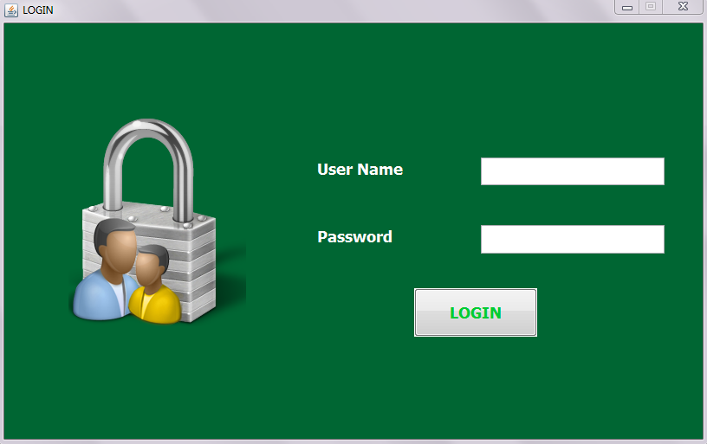

User should enter his correct username and password.

If user is an employee he will redirect to employee view main GUI.

If user is a manager he will redirect to manager view main GUI.

Manager view main GUI



Employee view main GUI

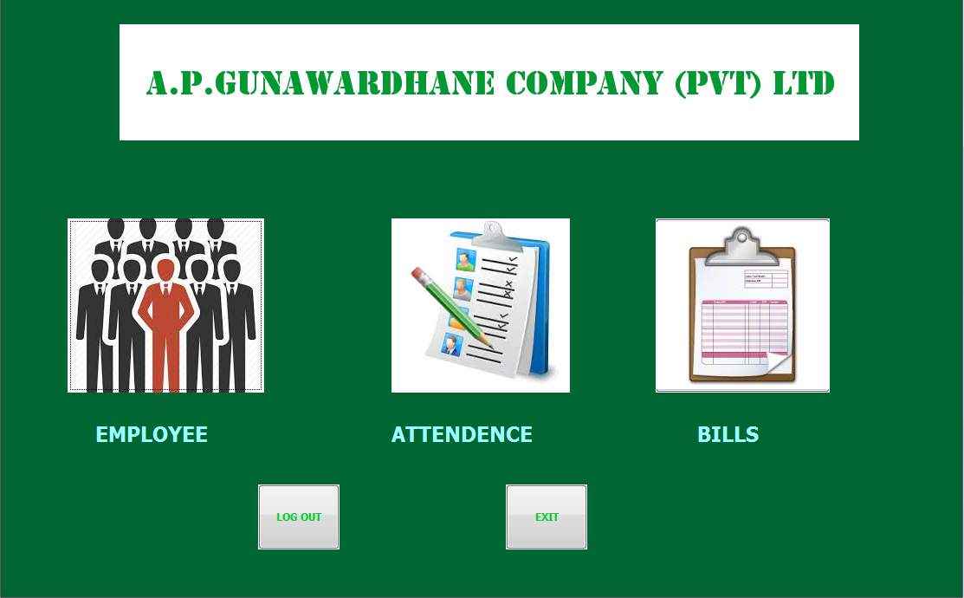

In Employee view main GUI EMPLOYEE category user can

View his personal details, apply leave/loan, view loan/leave history.

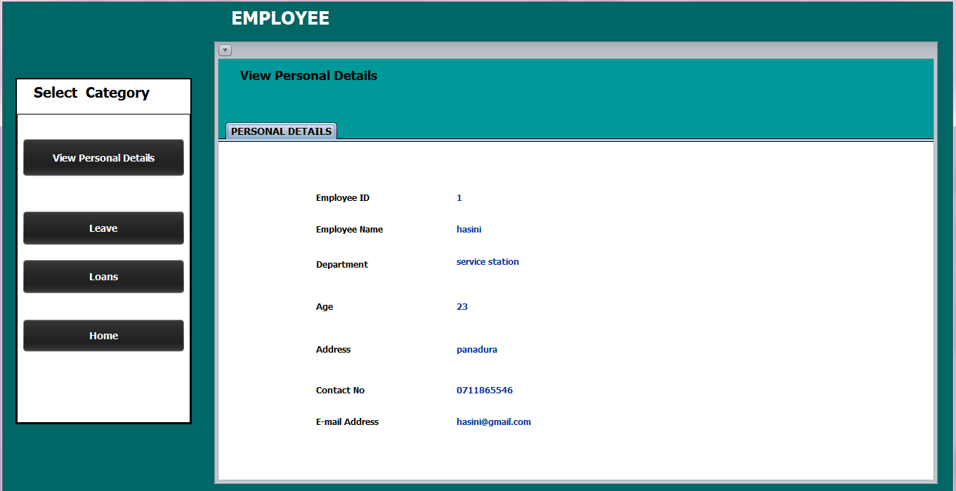

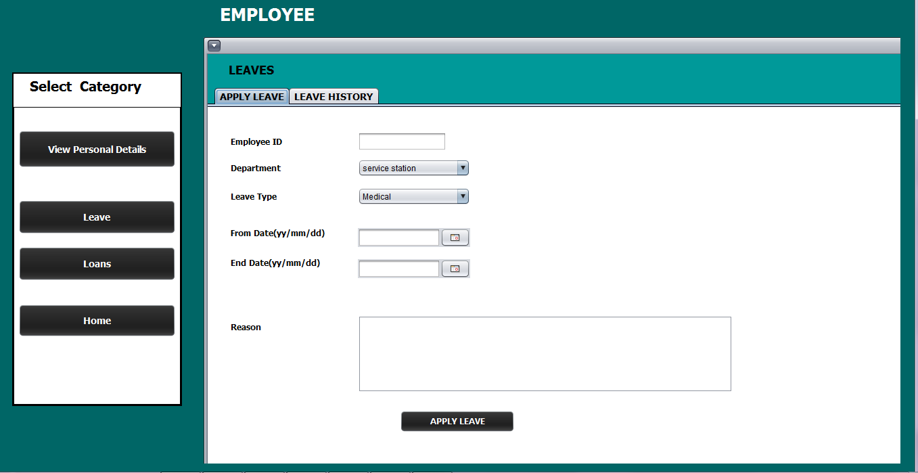

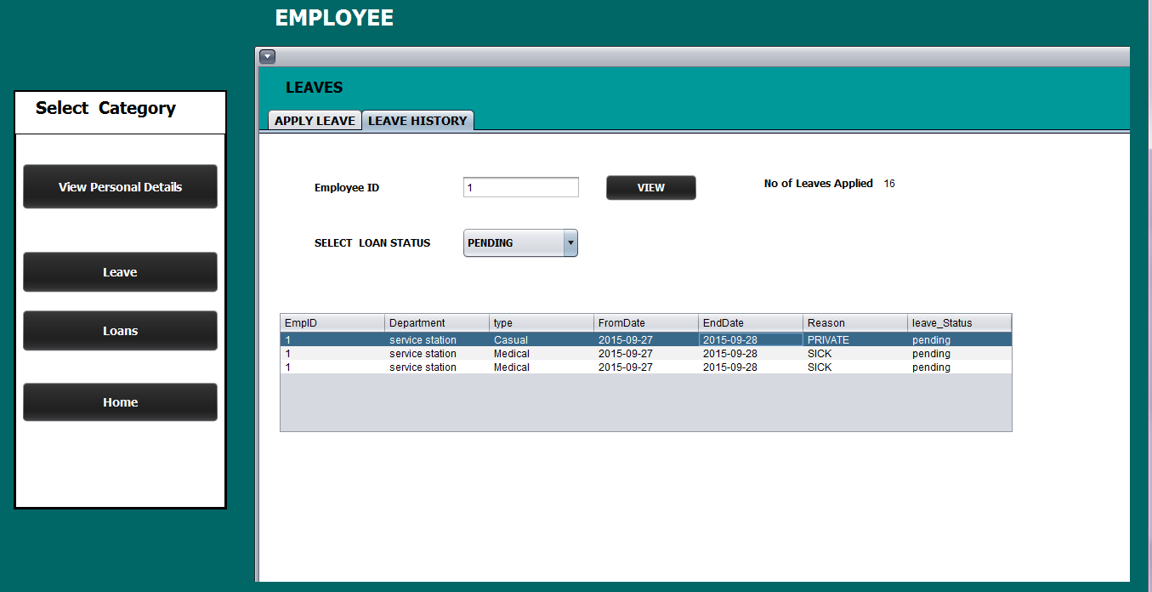

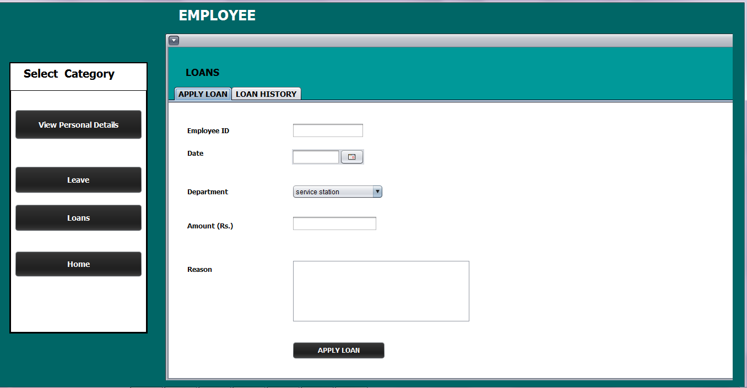

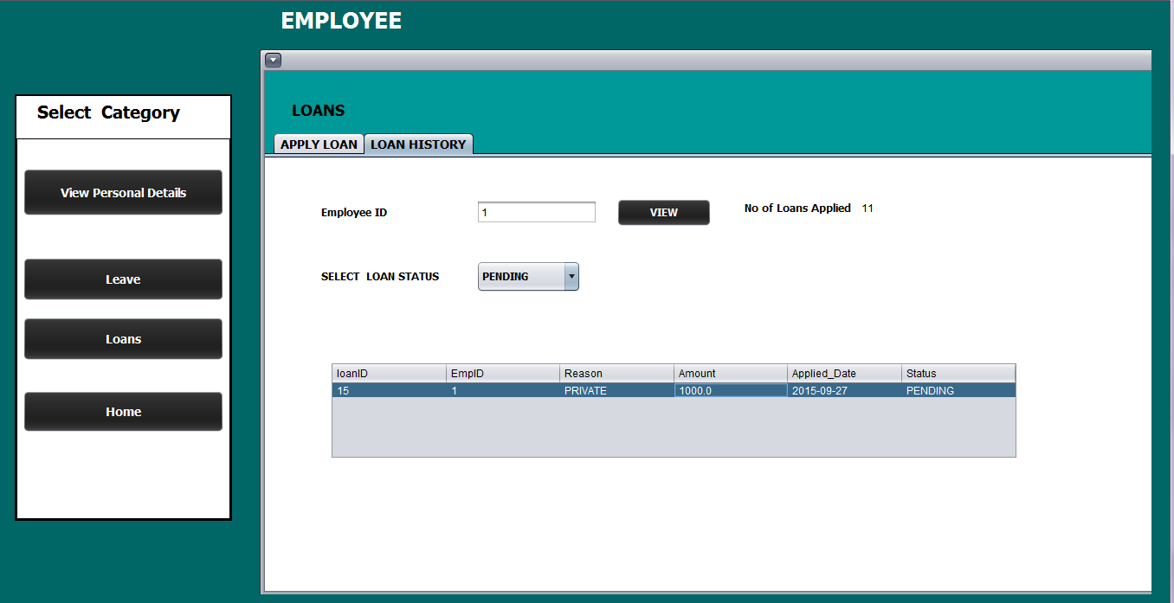

In Manager View main GUI HUMAN RESOUCE MANAGEMENT category user can

Add/update/delete employee/manager, issue user login data, approve/reject leave/loan, view reports

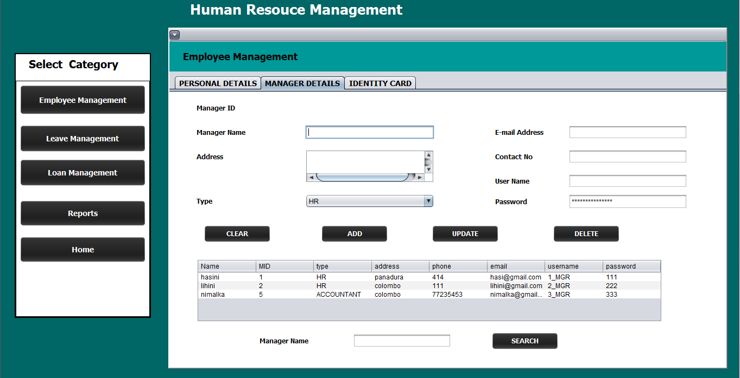

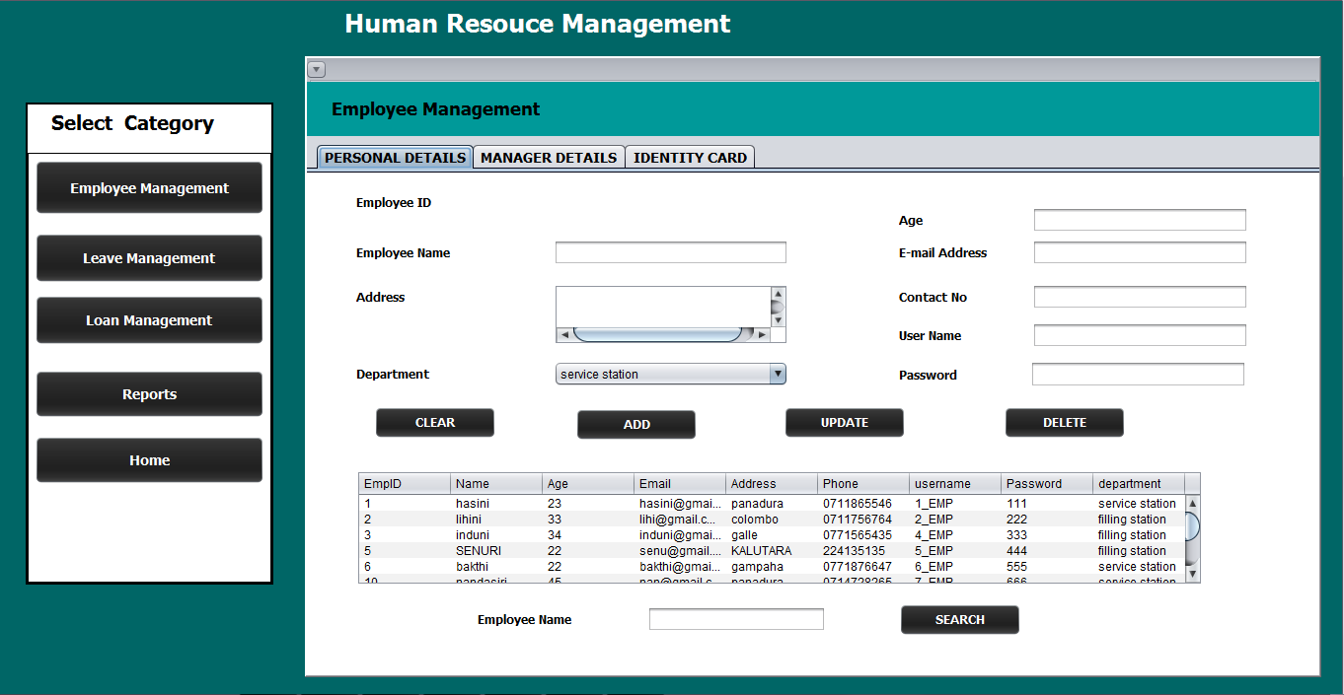

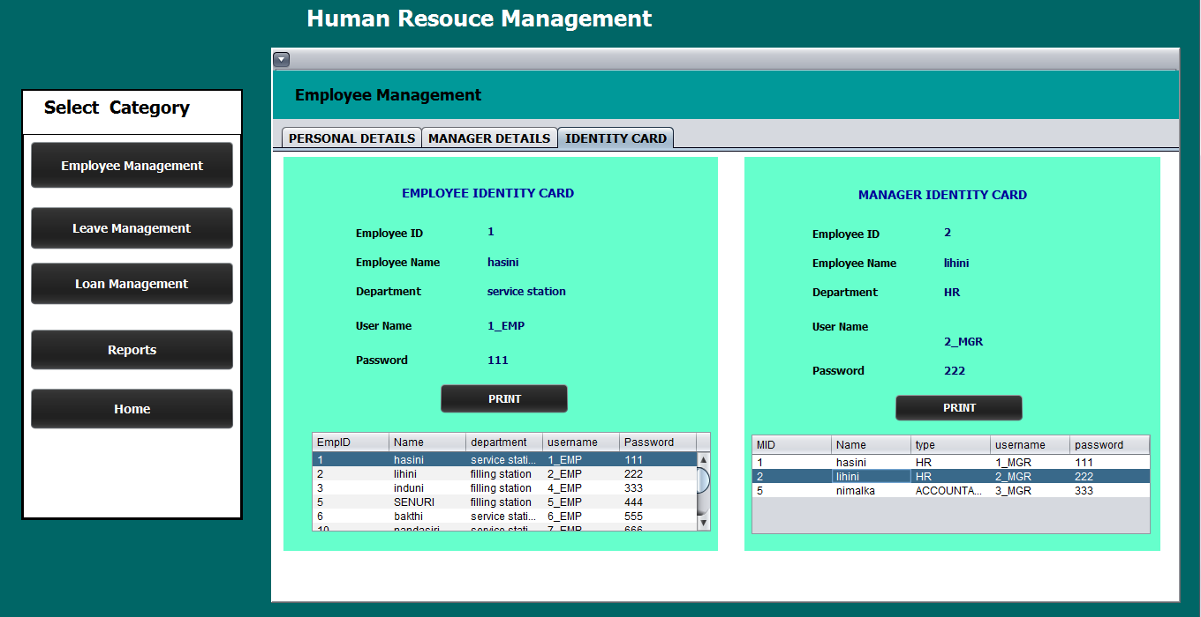

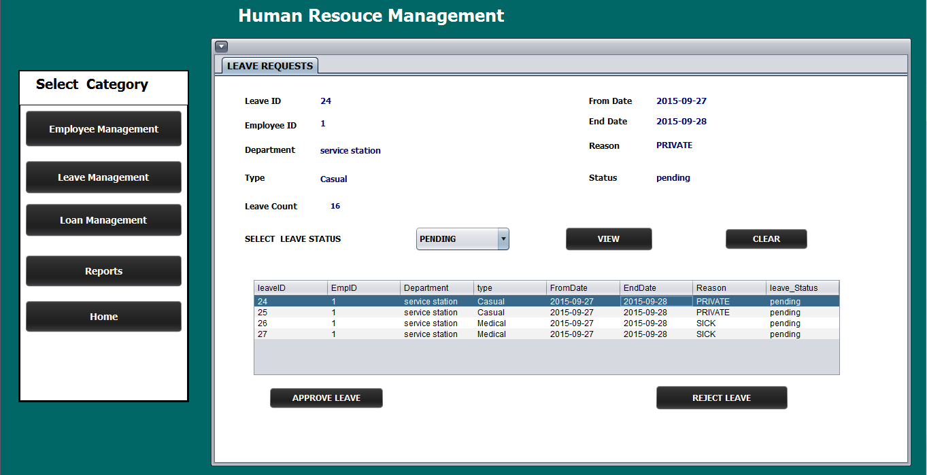

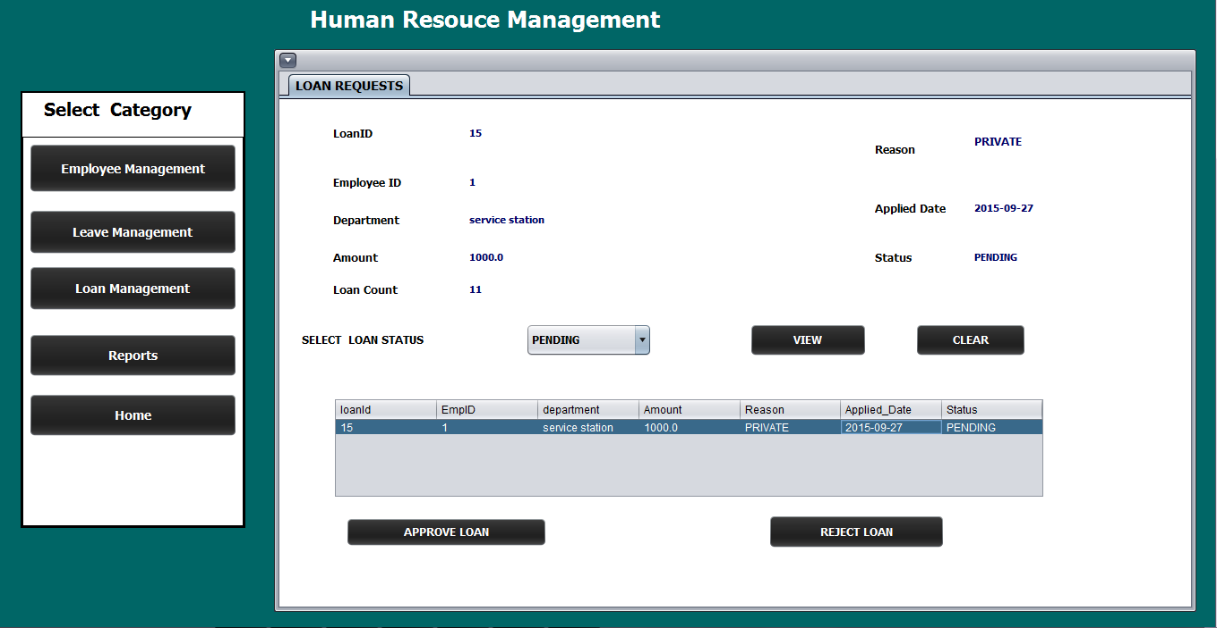

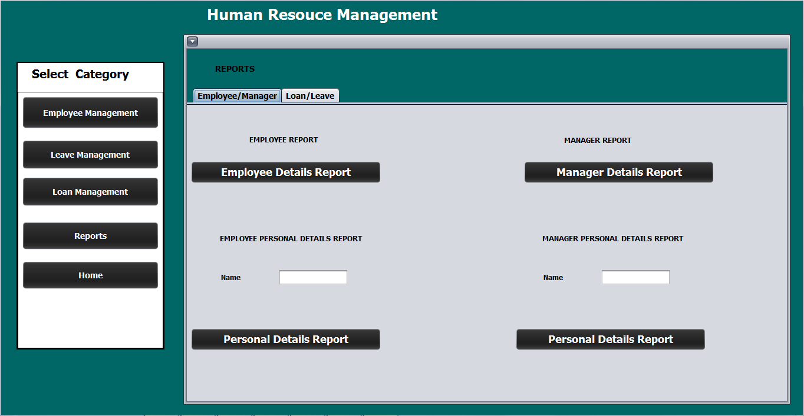

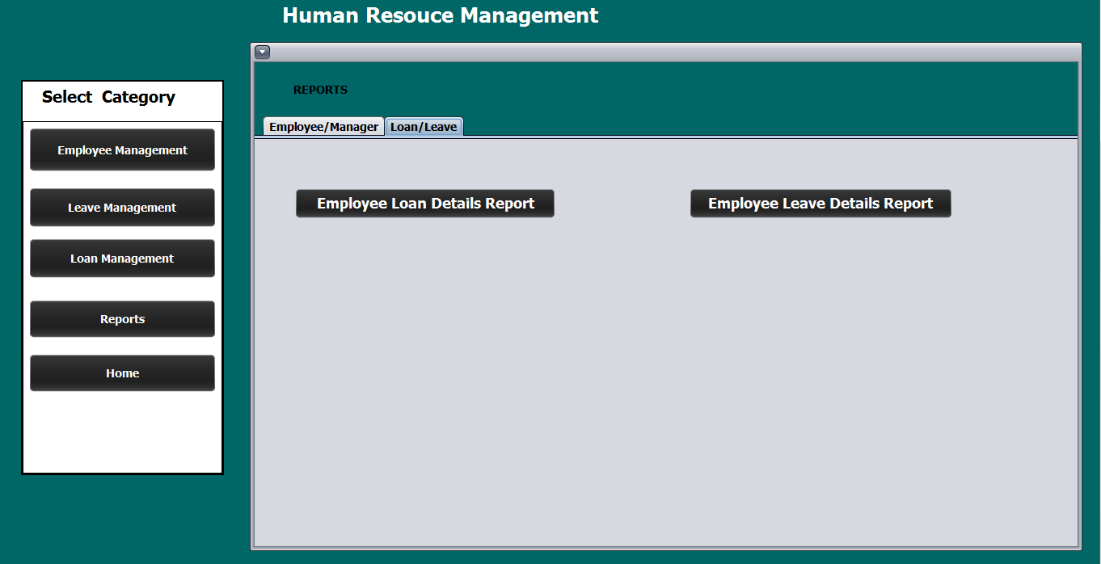

**FUEL SALES AND STOCK LEVEL MANAGEMENT.**

In Employee view main GUI BILL category user can generate Lubricant bill using “Lubricant” interface and handle Meter readings using “Meter Readings” interface.

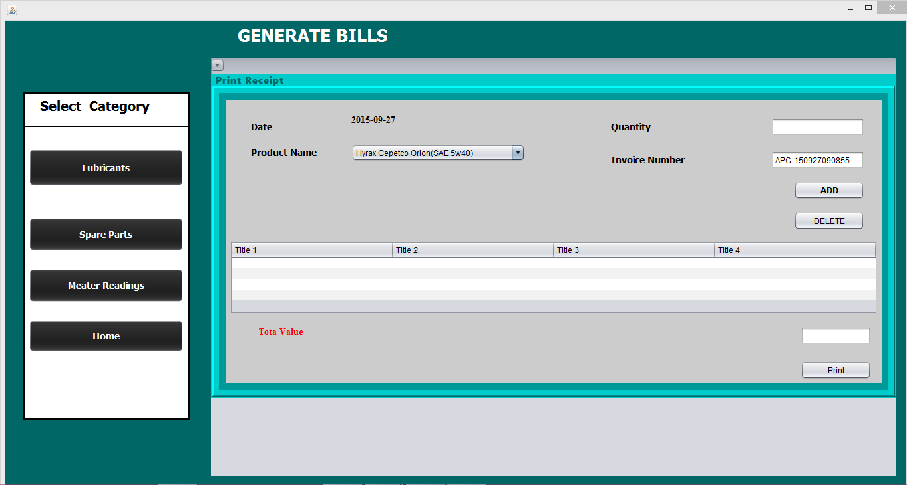

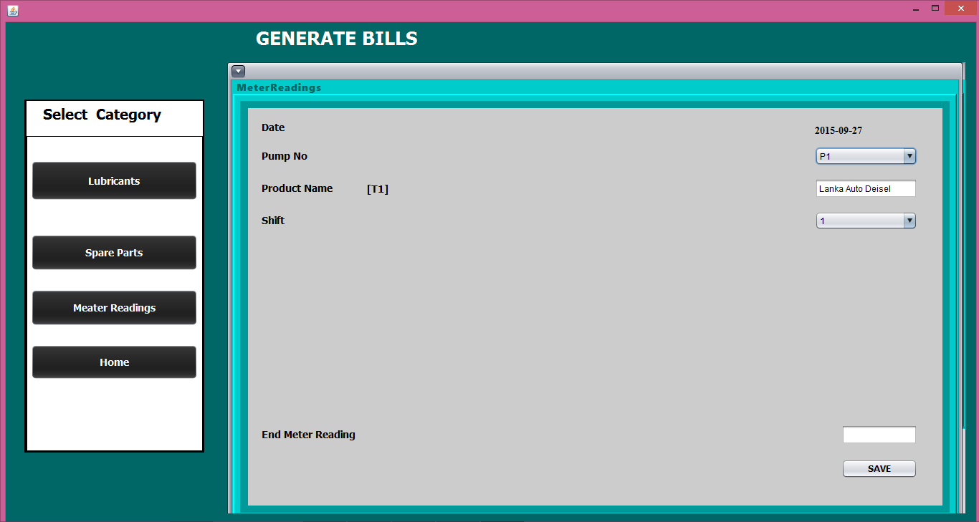

In Manager View main GUI FUEL SALES AND STOCK LEVEL MANAGEMENT category user can Add/update/delete/search product details (fuel and lubricants) and Machinery details (pump and tank) using “Add product details” and “Add Machinery Details” interfaces.

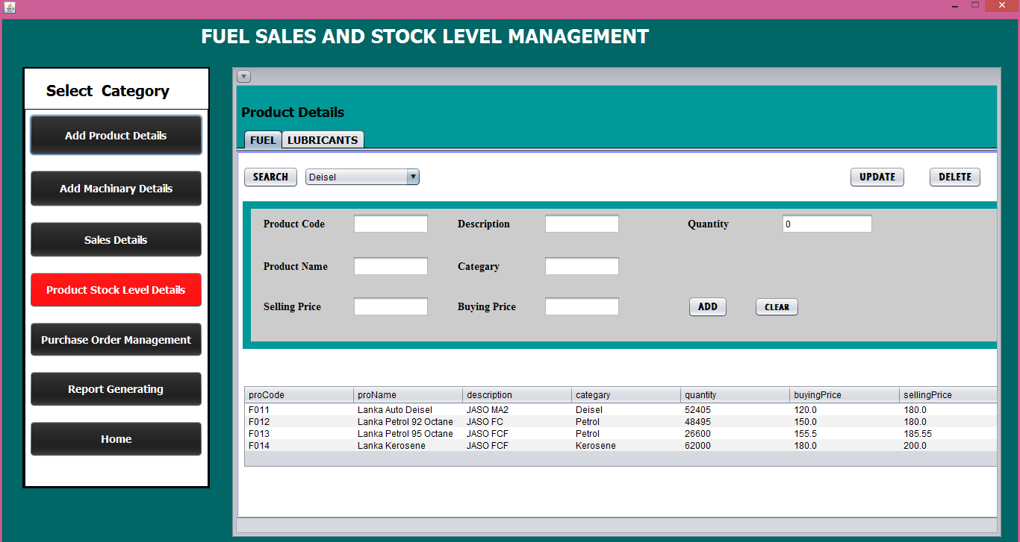

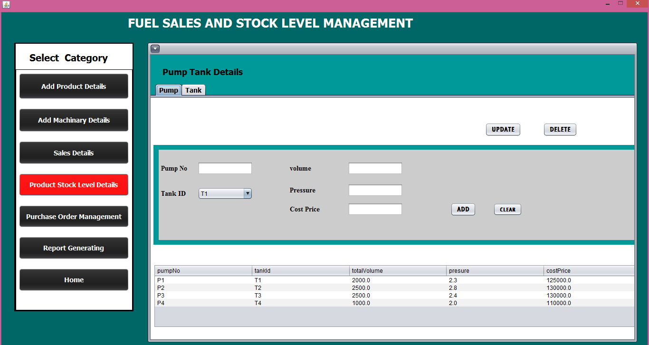

User can summarize both fuel sales and lubricant sales information based on user defined criteria using “Sales details” interface

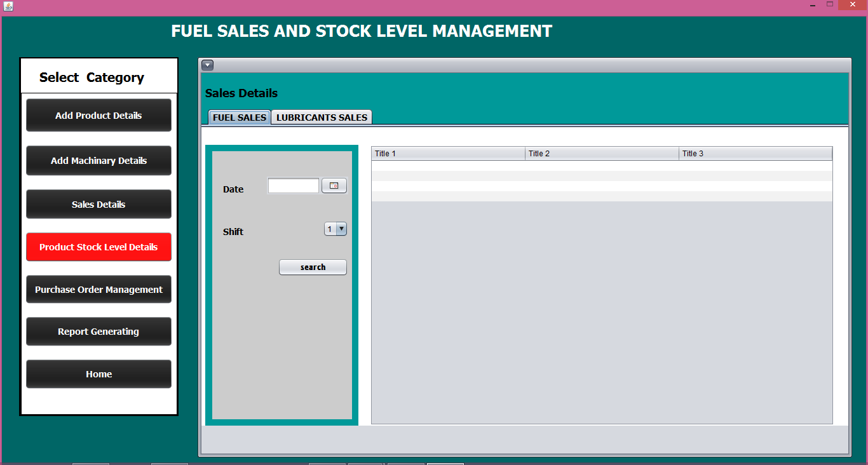

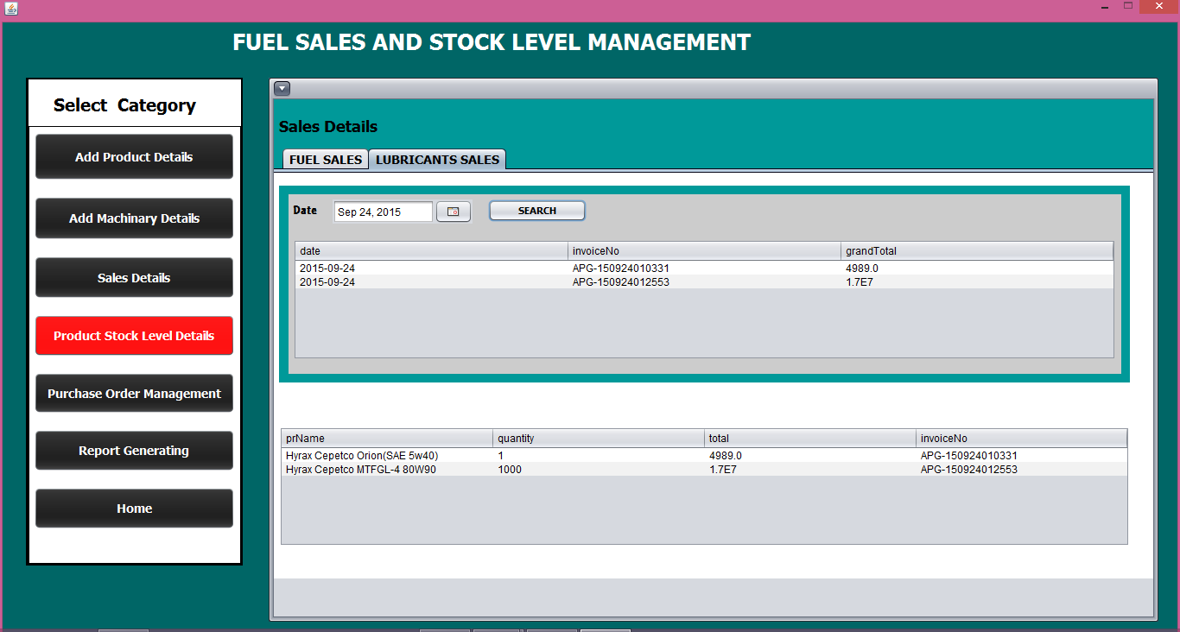

User can go through both fuel tank and lubricant stock level status using “product Stock Level” interface.

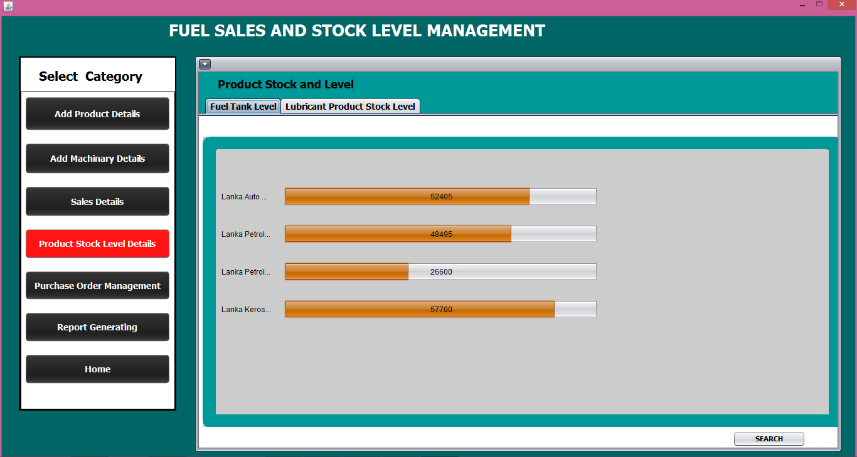

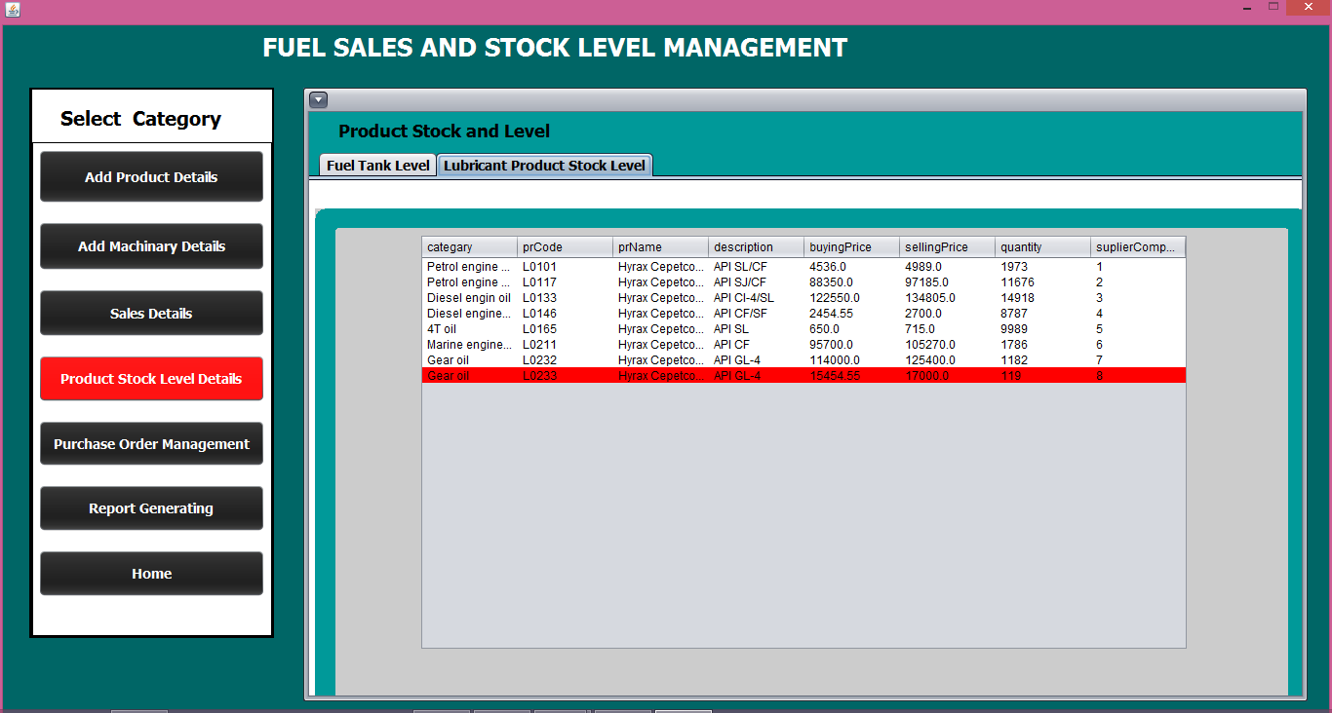

User can manage supplier details, request order details and received order details using “Purchase order management” interface.

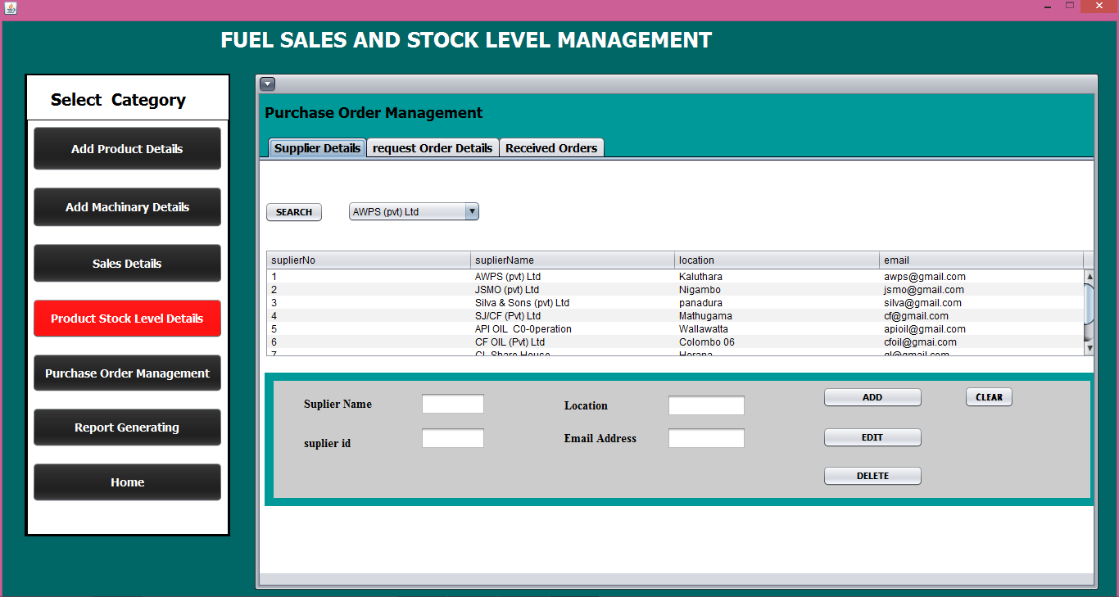

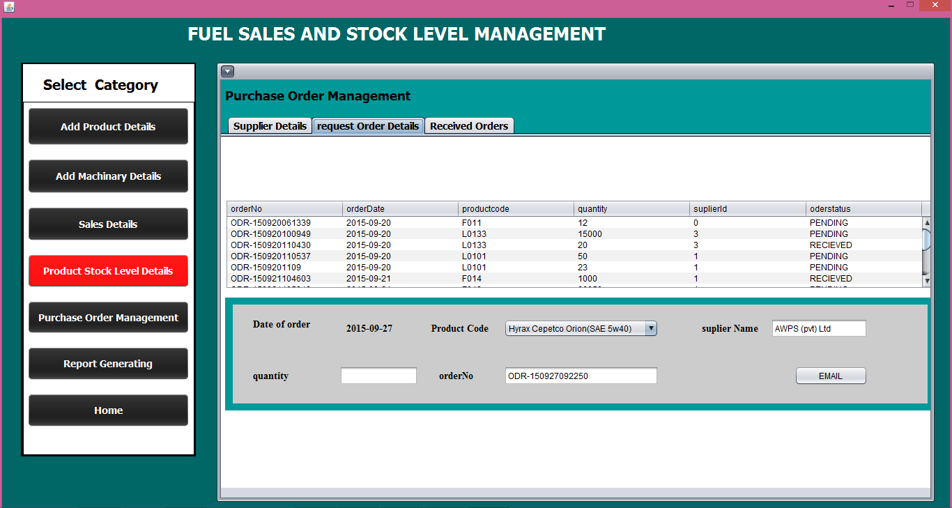

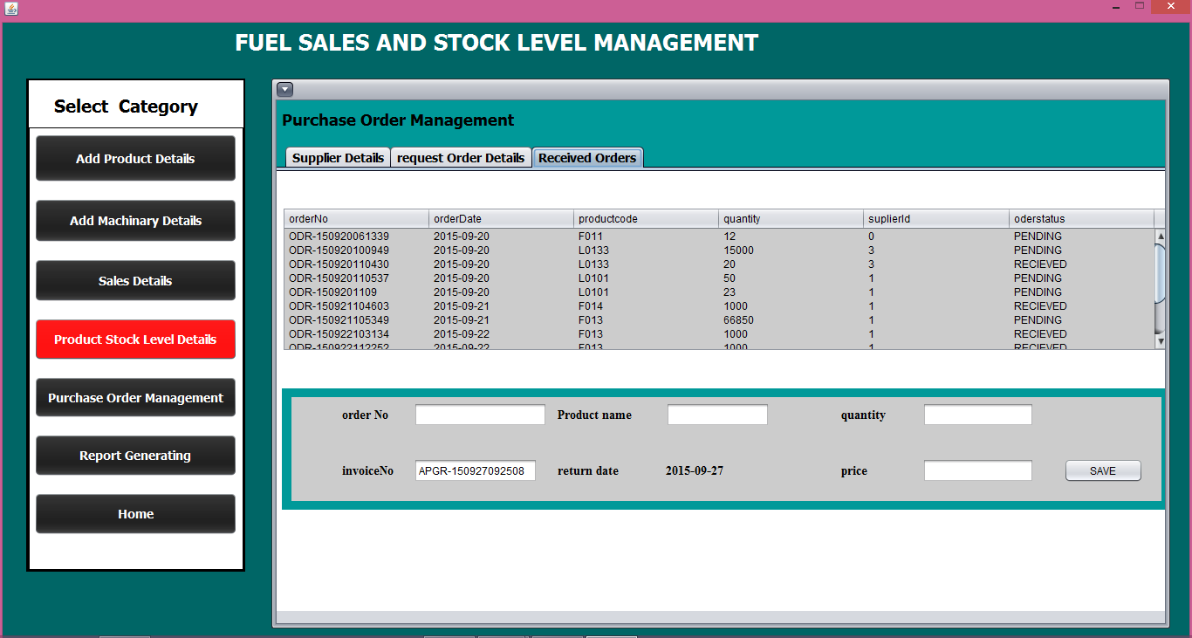

User can preview overall sales income and daily sales values information on both fuel and lubricants separately as reports using “Report Generating” interface.

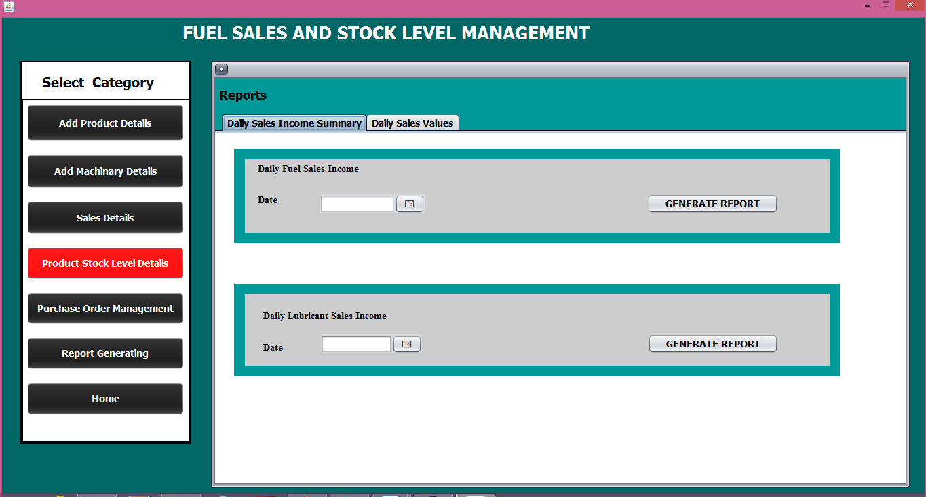

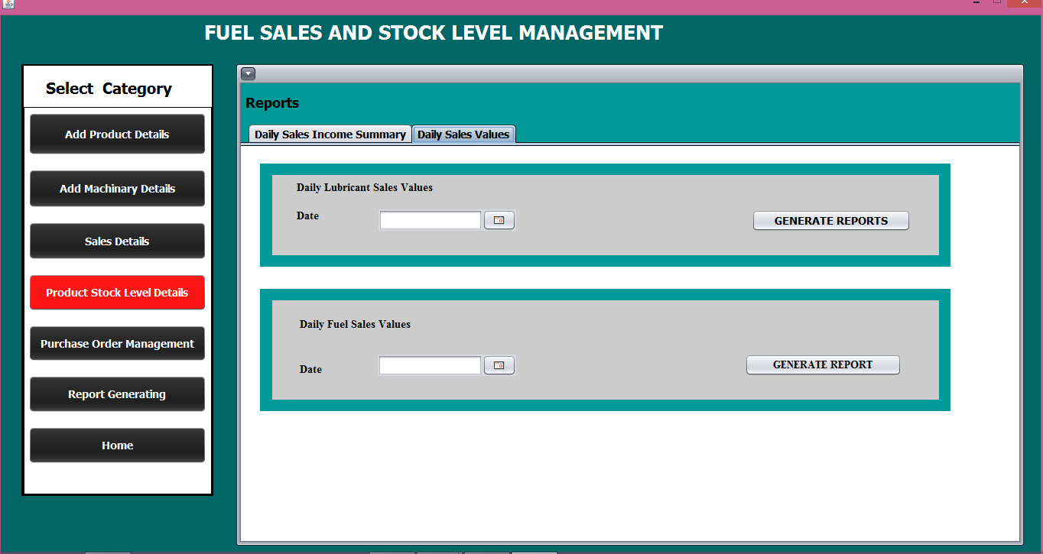

**CUSTOMER SERVICE MANAGEMENT**

User can register, update or delete the general customer.

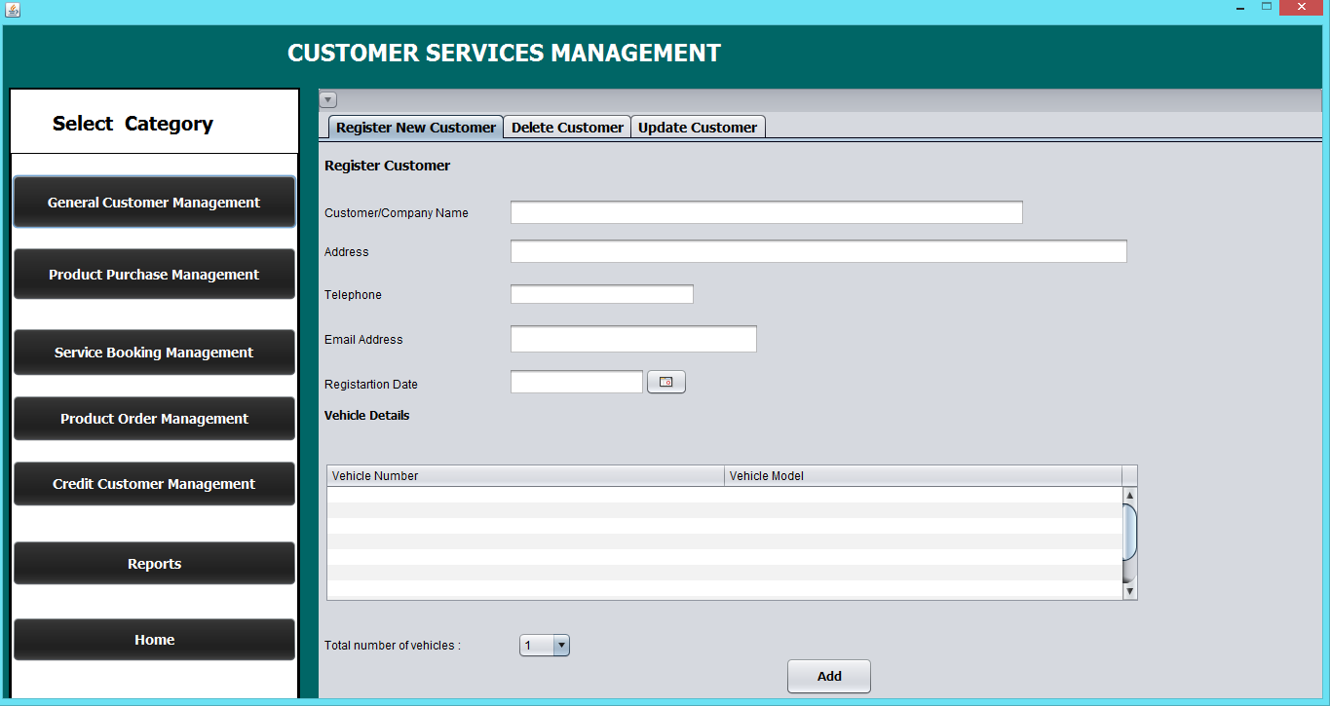

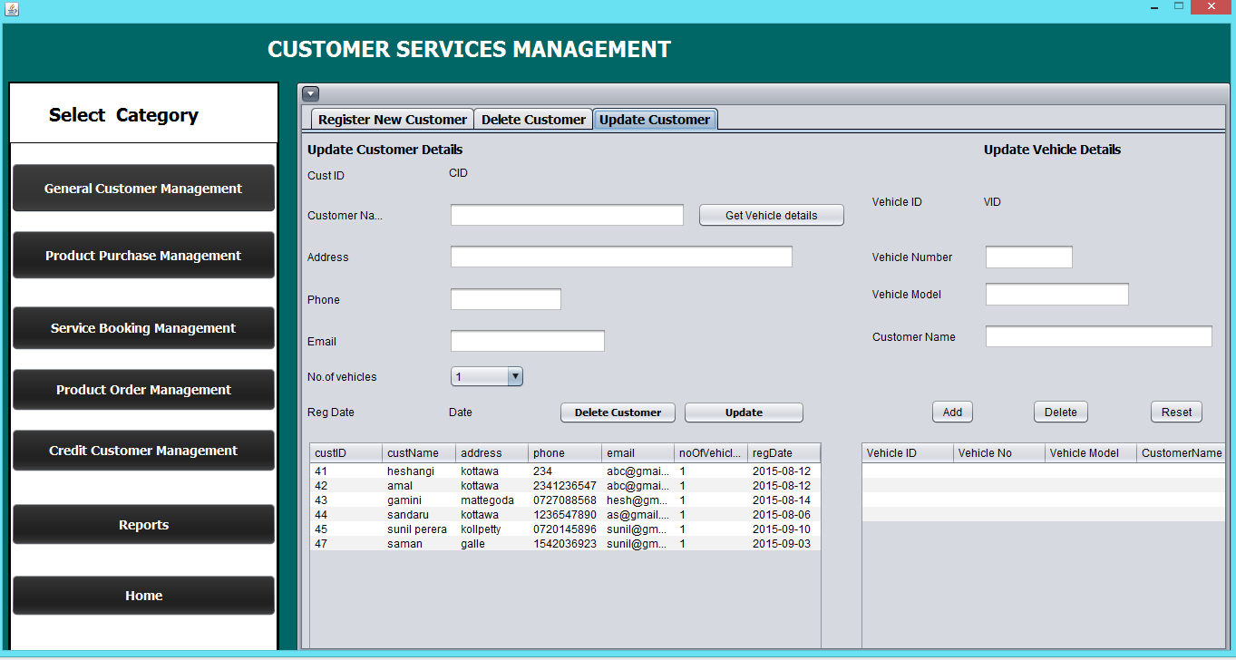

And then user can update the service station product stock too.

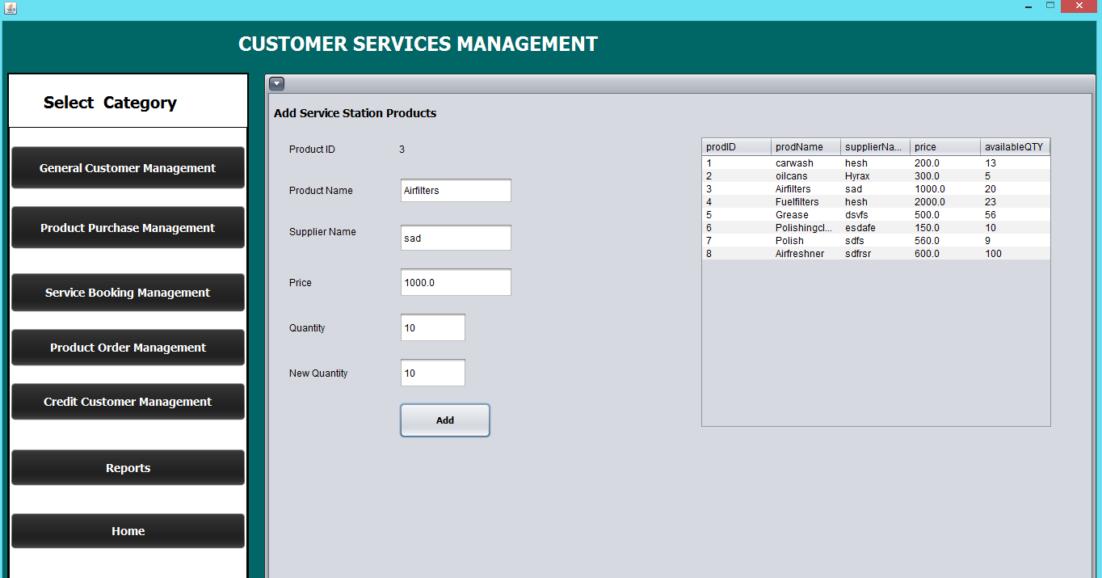

And User can do the Service bookings or delete or update them as necessary.

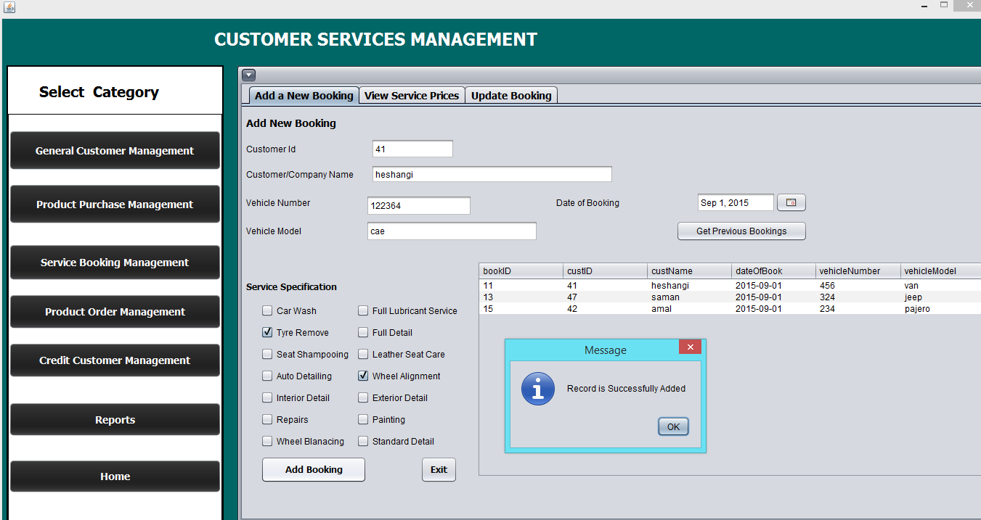

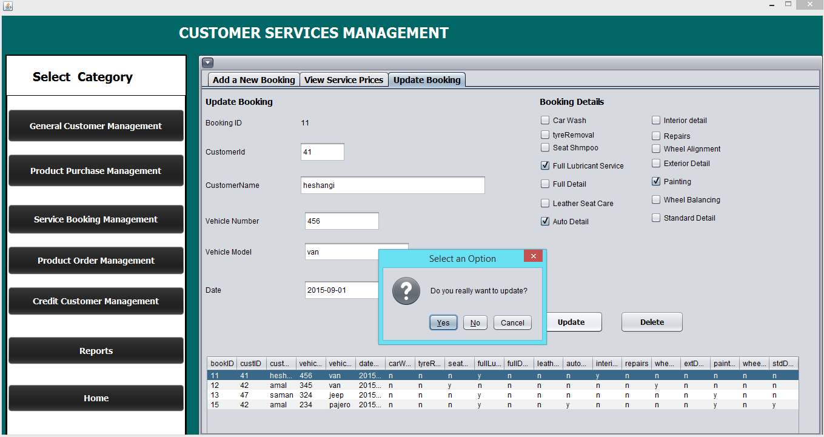

And also user can view the service prices if necessary.

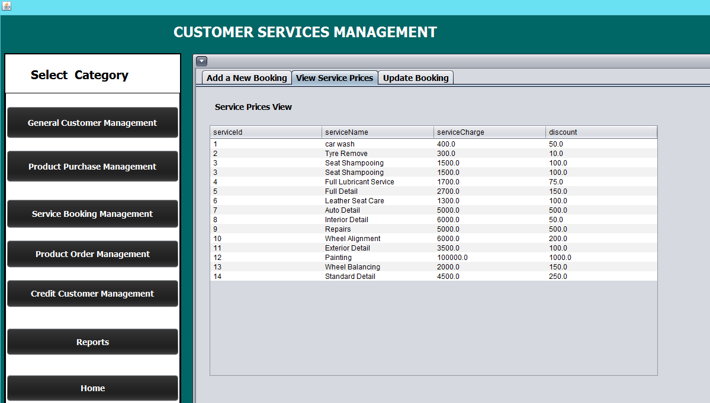

And in the product management interface user can add product order bookings, update them or delete them.

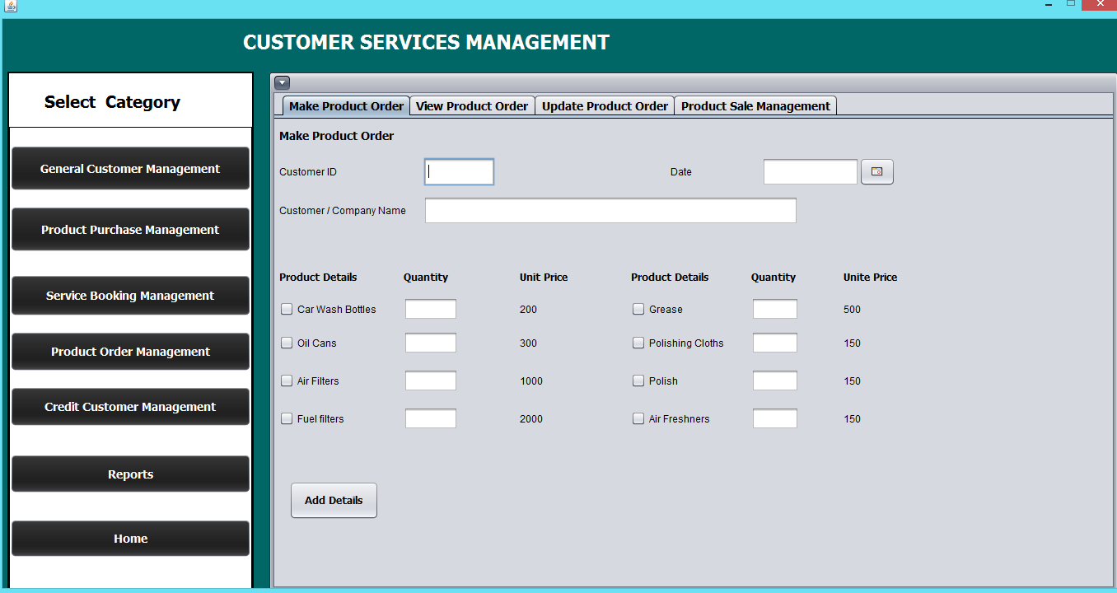

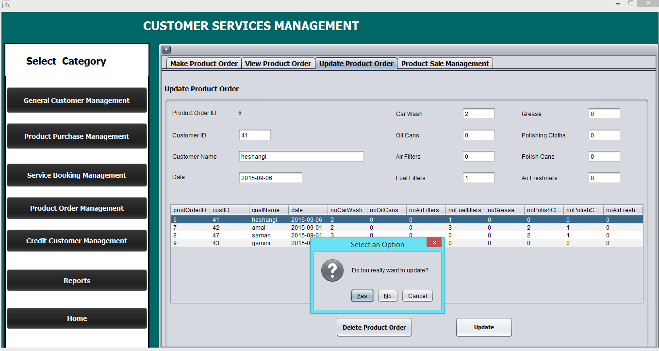

Or user can perform the product sales also.

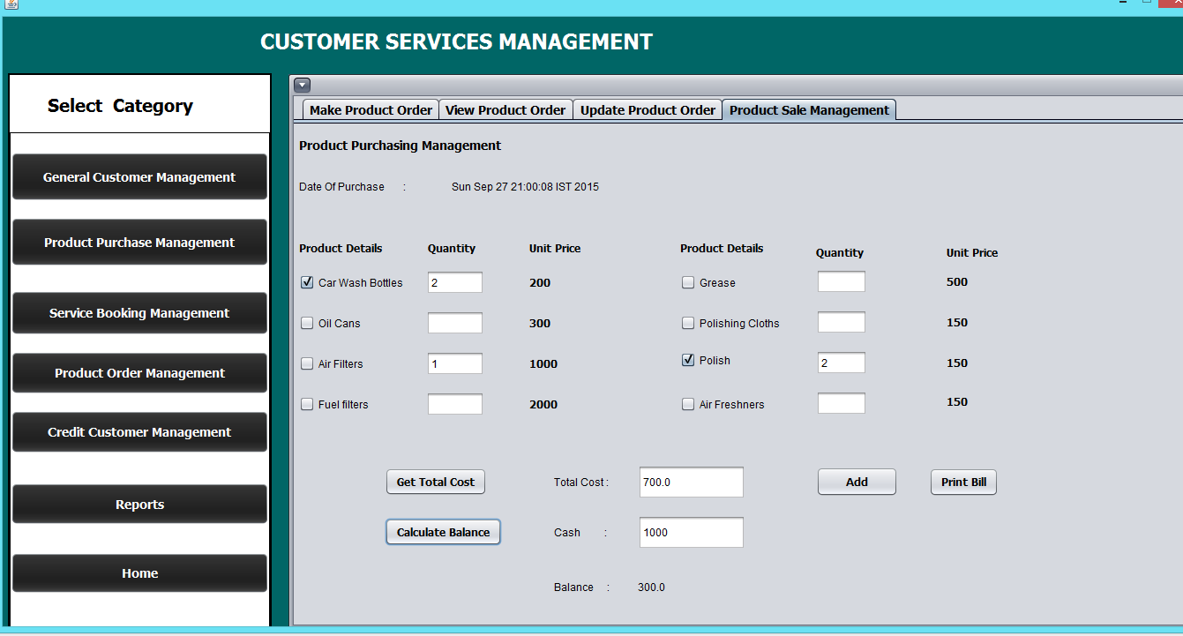

Else he can view product orders and print order detail slips.

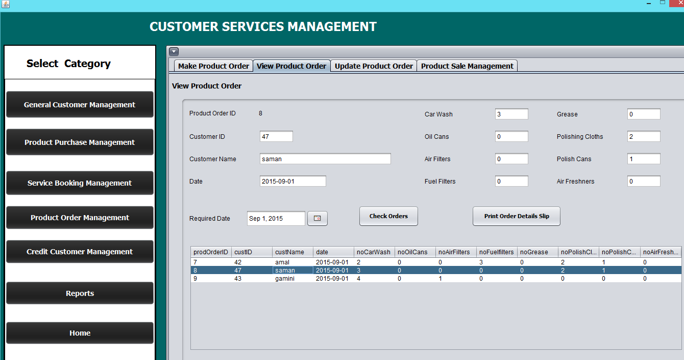

In the credit customer management user can register customer and add deposit amounts to that customer.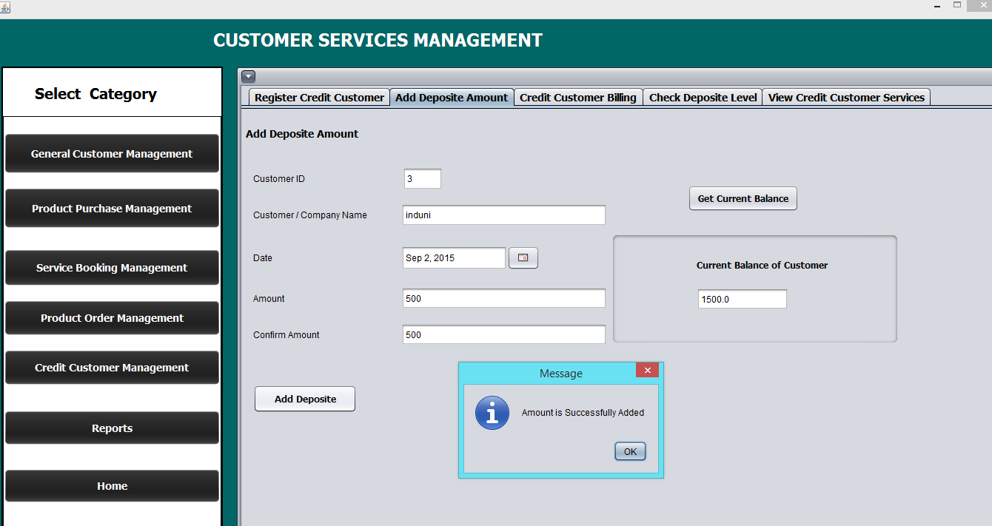

And then he can check deposit amount of a specific customer and send alerts.

Then again he can change the minimum deposit amount as necessary.

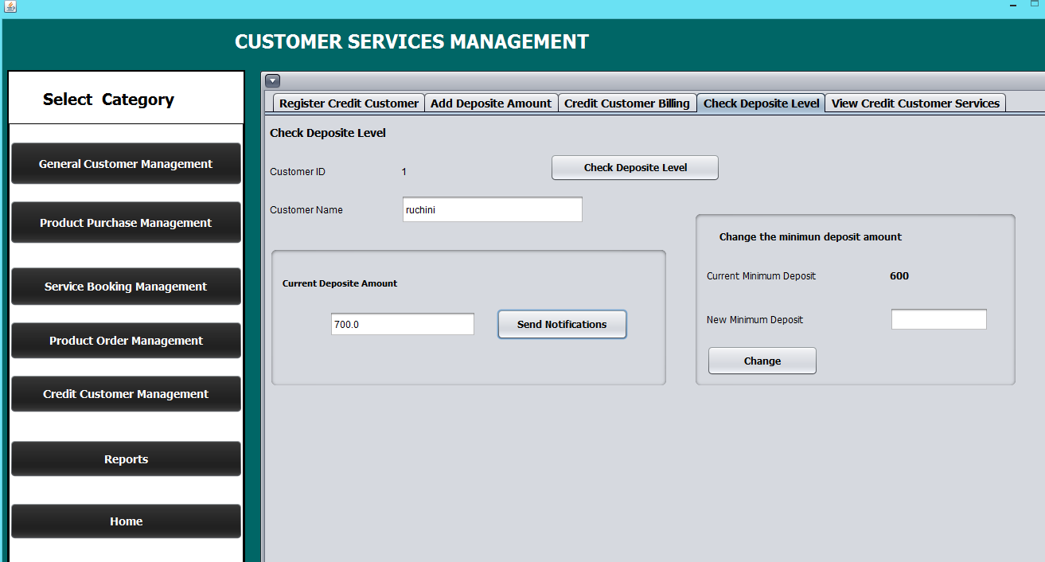

User can do credit customer billing and view the services obtained by the specific credit customer.

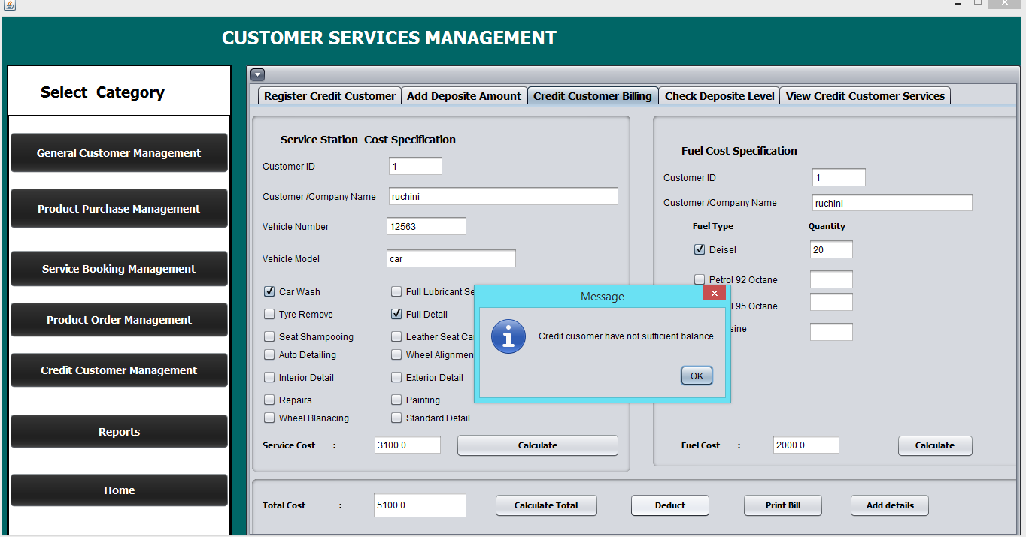

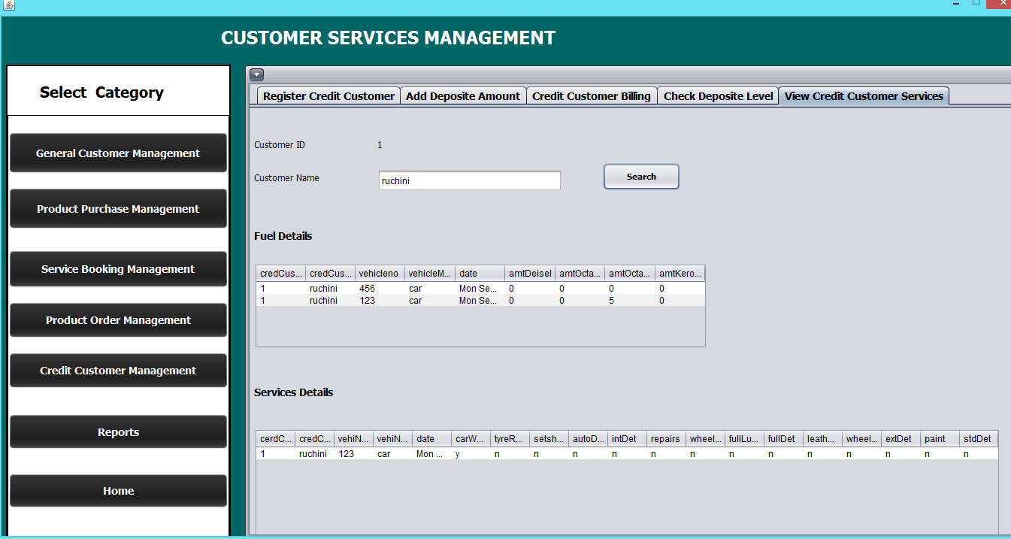

**SPARE PARTS MANAGEMENT**

Once the user logged in to the system as Manager View the user can add and update the inventory stock of spare items , view spare items images (available in the database), view spare parts stock level ,through these interfaces. And user can view the current date and time dynamically on the above of all the interfaces of spare parts management.

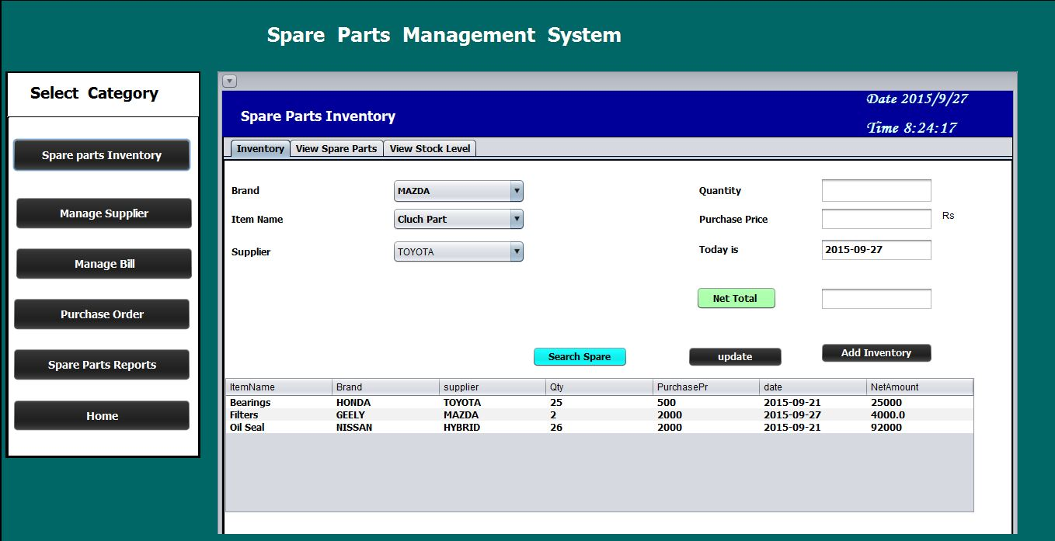

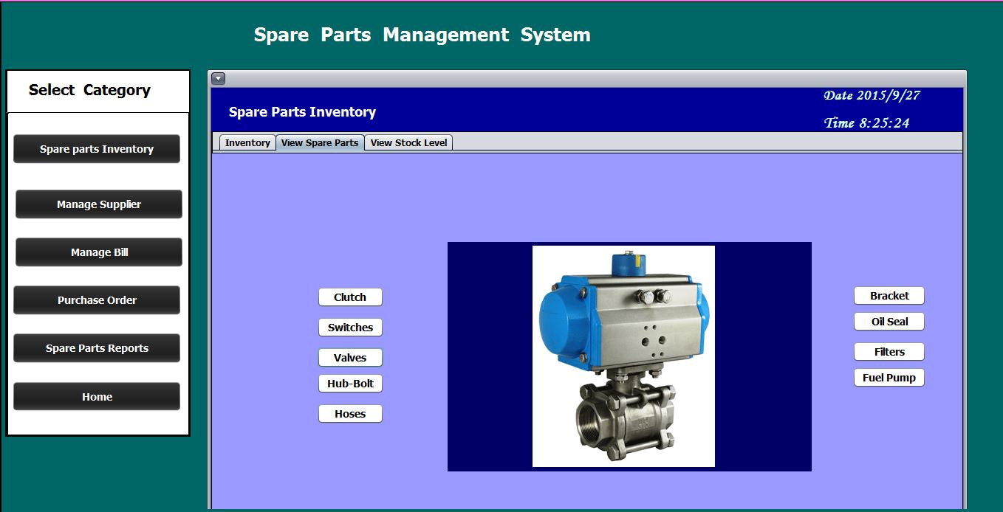

If the particular spare part item reaches the re-order level the user can order the items from suppliers through this interface. Once user typed an item name the system only takes the characters if the user type digit accidentally the system will makes the beep sound and prompts a message. The given buttons will redirect to the particular suppliers or G-mail Account simply.

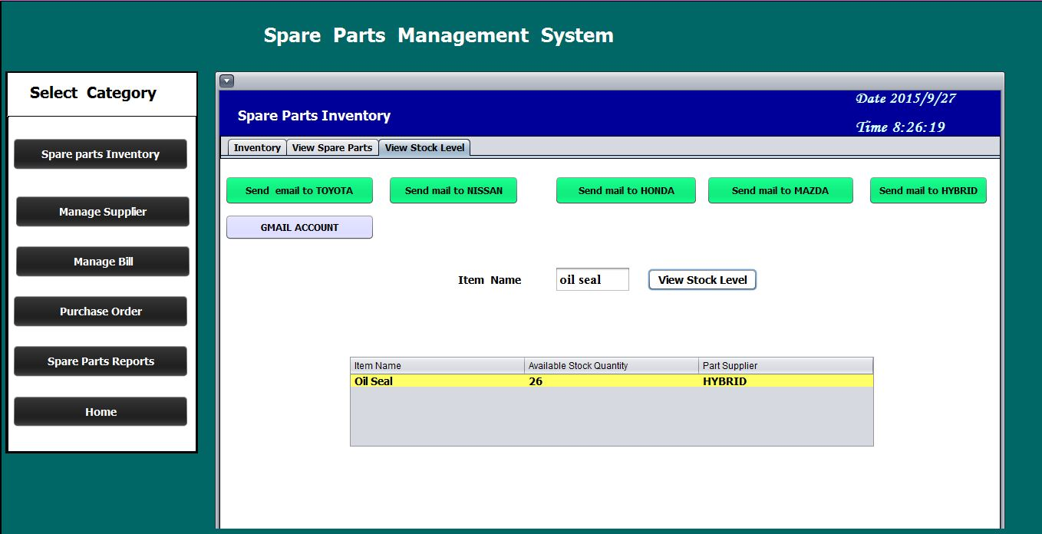

Once the user logged in to the system as Manager View the user can add update and delete the purchased order details and the user can inform suppliers(if any) by this interface as well. And user can view purchased order history and search particular purchased orders. Total net of order item’s calculations also will be display in this interface. After adding the purchased order item details the stock will be increase in the spare part stock.

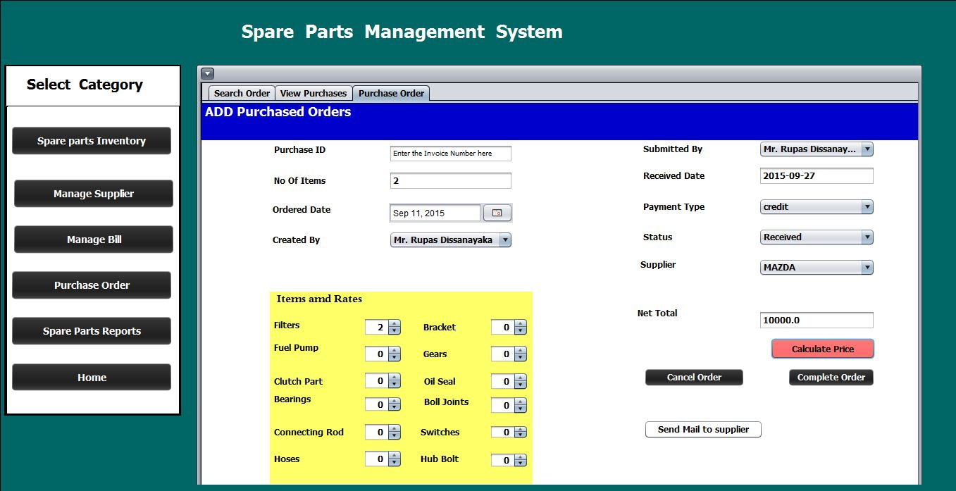

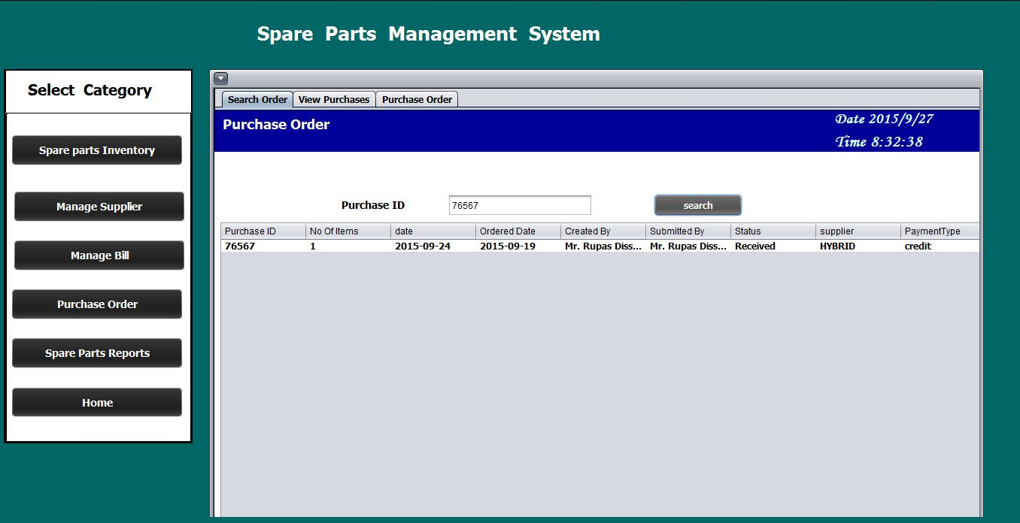

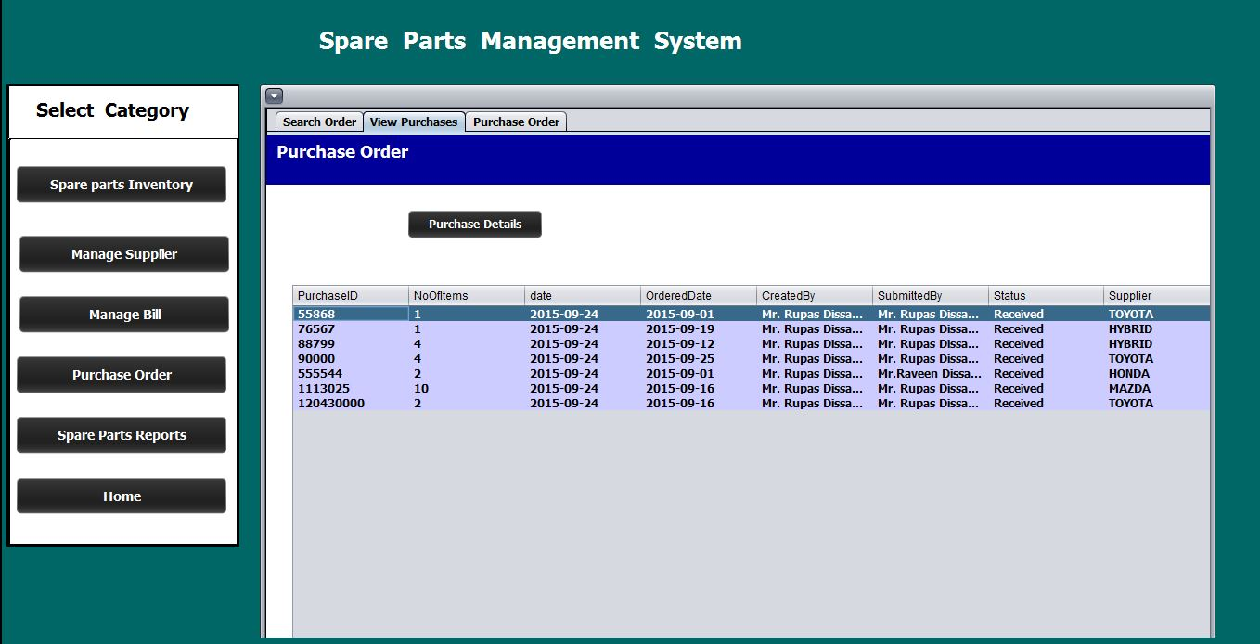

Through this interface user can simply see the particular bill detail of issued spare parts items grouped by customer name.

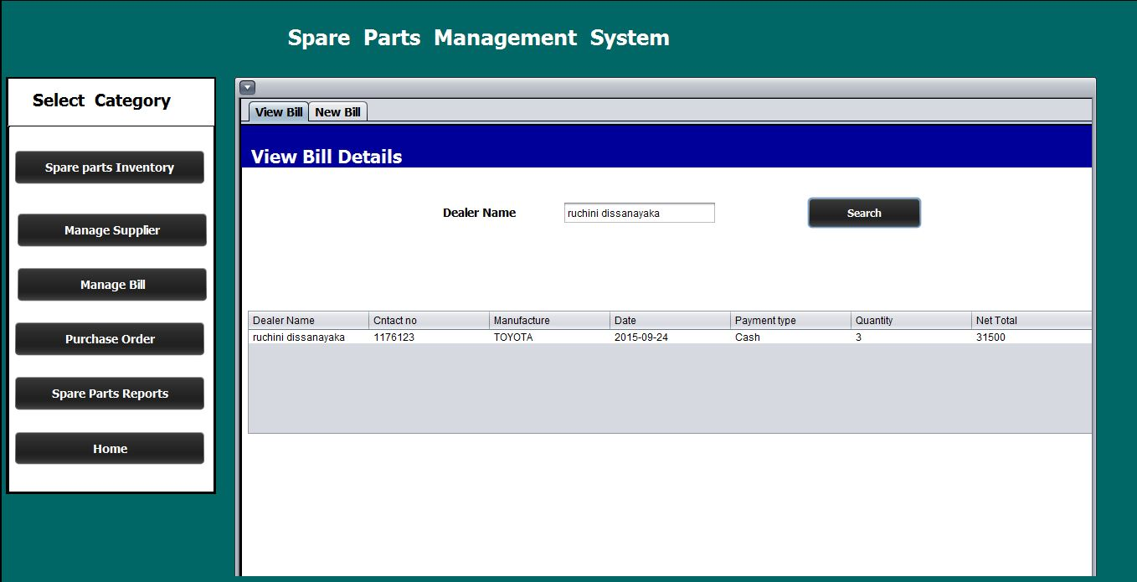

By this interface user can issue a new bill for spare parts items. Once the no of items selected by the spinners and after pressing the net total button the price will be display in the net total text box. And the balance also will be calculated and display here. Once issued an item that item will be deducted from the stock.

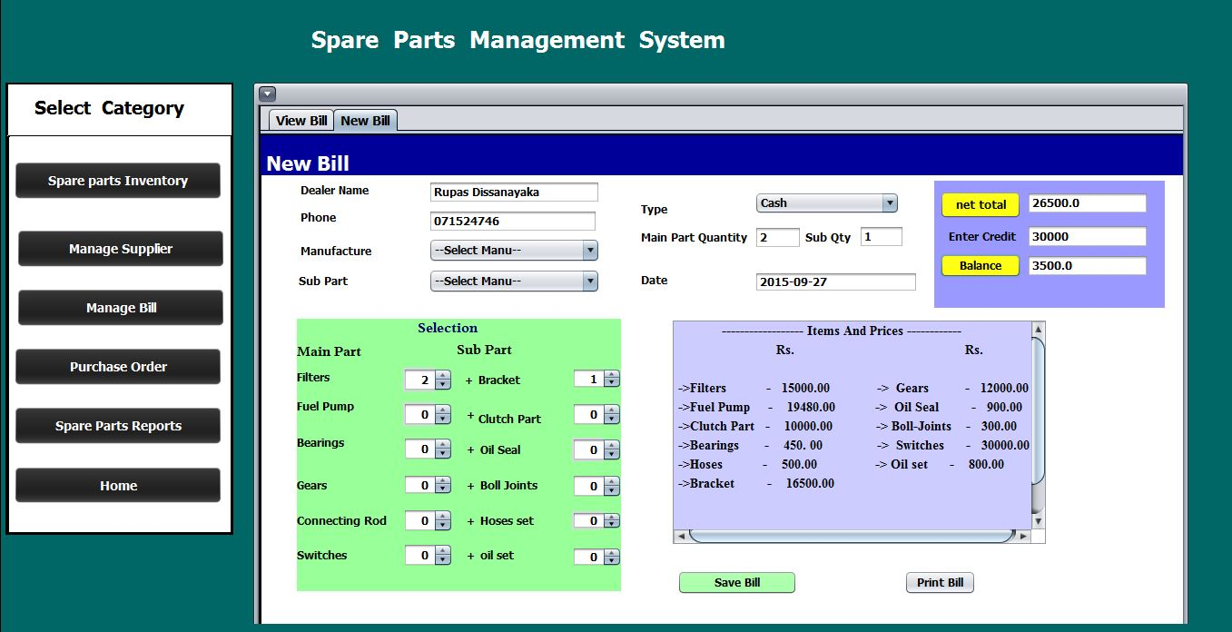

The will be printed as pdf here. But the details of bill will be limited here because of the warranty card and spare part item detail card which issued manually.

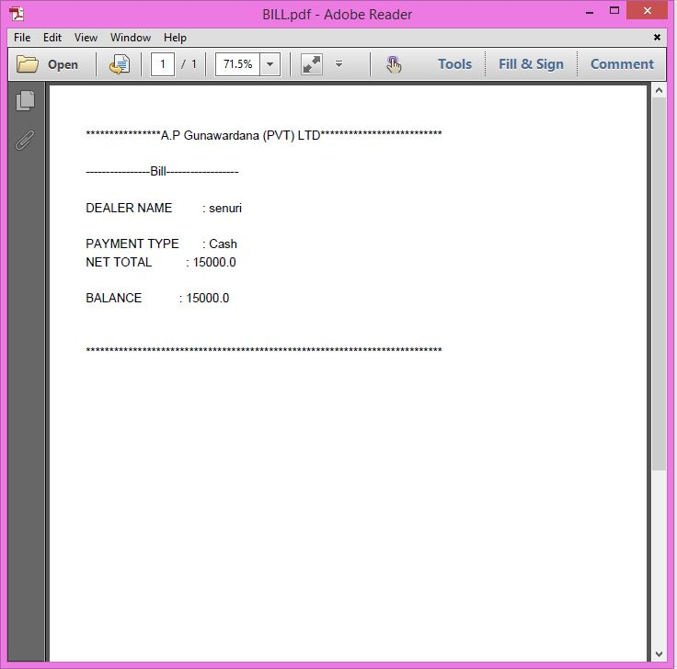

These interfaces provide the facility of add, update and delete suppliers.

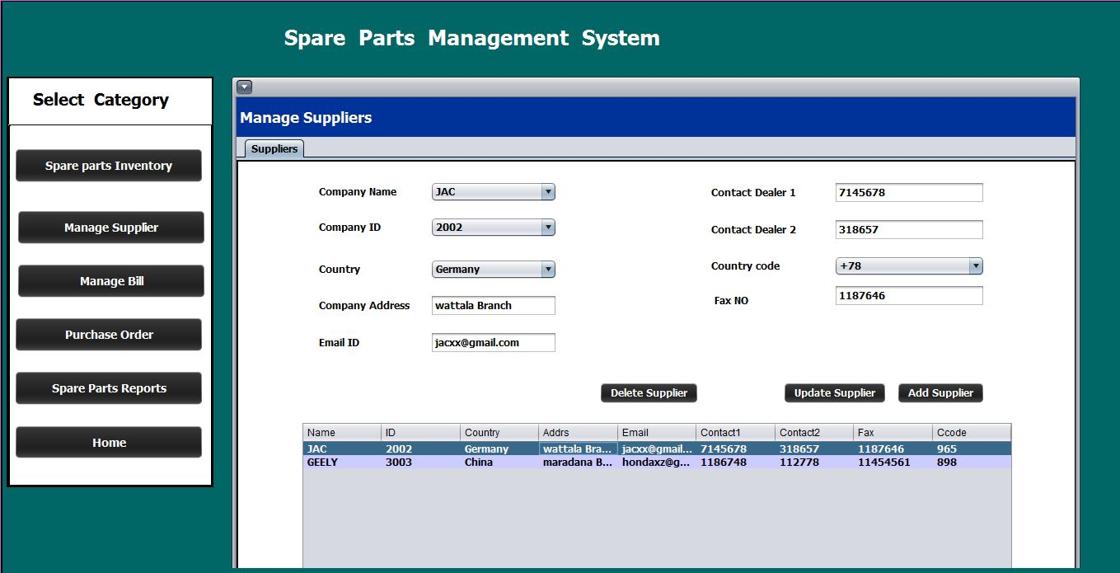

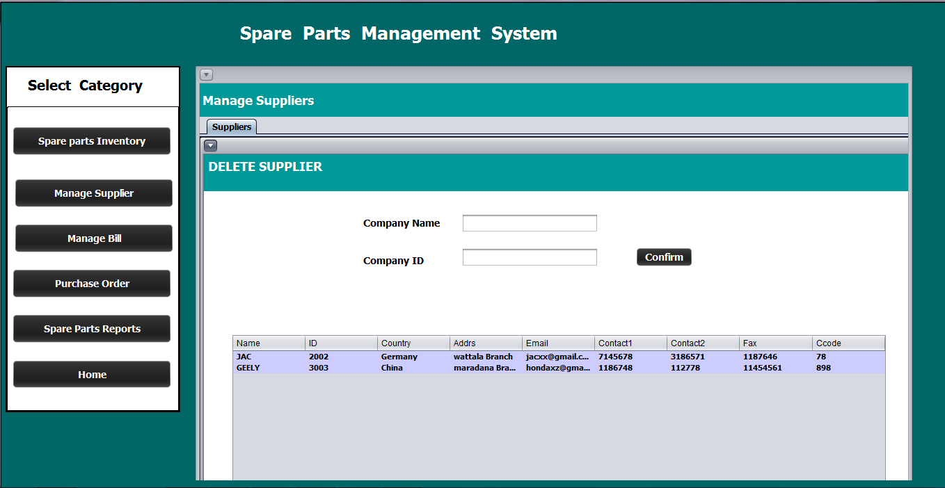

This interface provide the facility of view the summary of Bills, Inventory stock, Supplier and Purchased Orders.

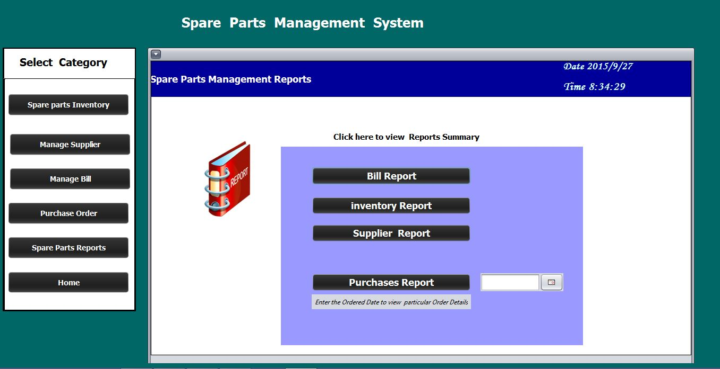

Generated Reports

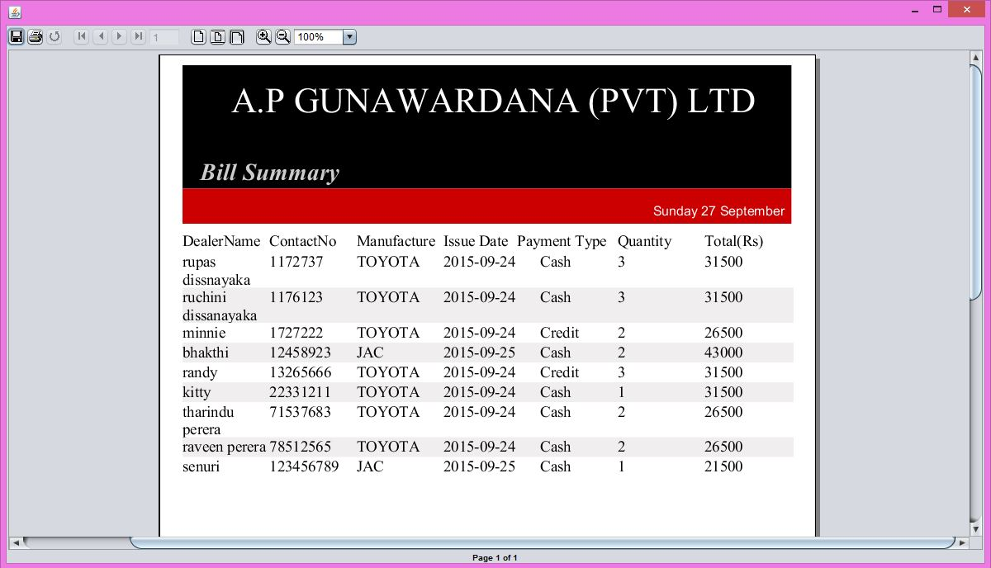

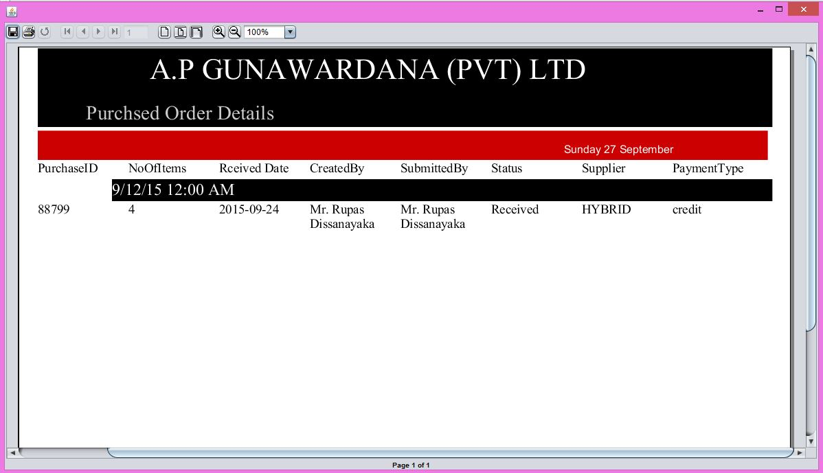

**MACHINE SUPPLY MANAGEMENT**

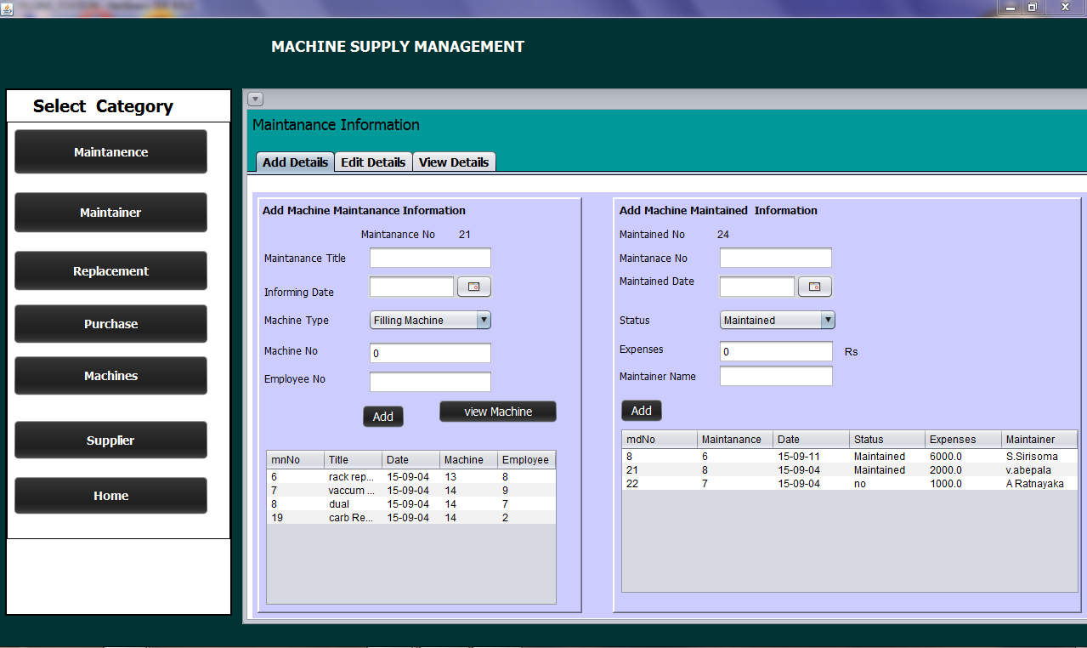Maintenance UI

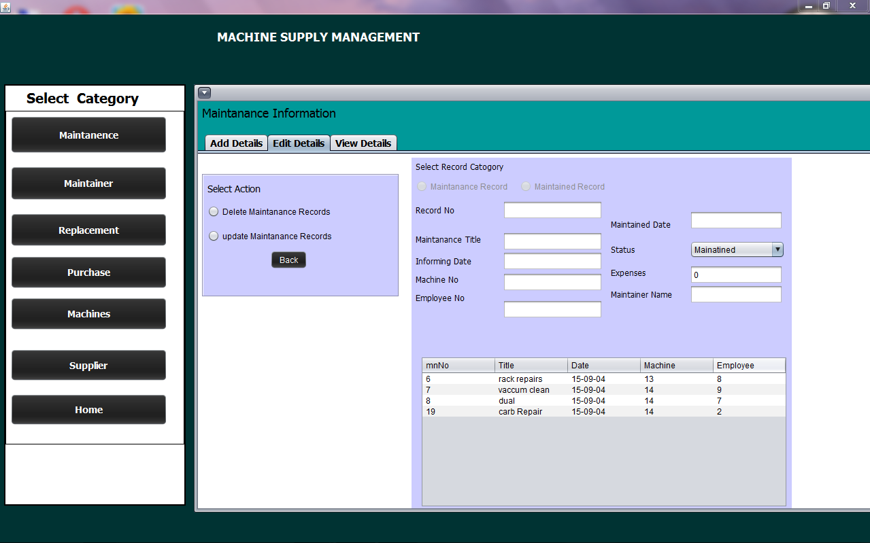

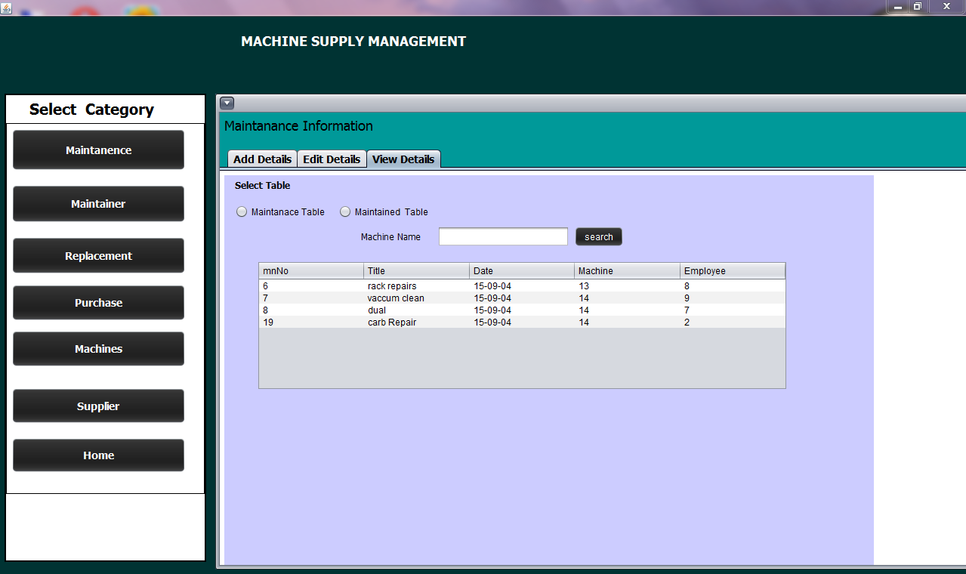

Section consists with 3 sub sections. Add details section provide the facility to add details to the maintenance database. Edit details can be used to update and delete details. Using View Details can view the informations.To add Maintained details Maintenance record that relevant to the maintained record should be in the database.

Maintainer UI

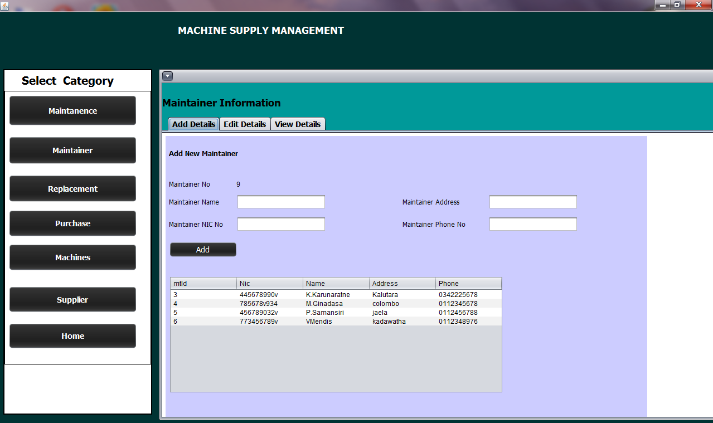

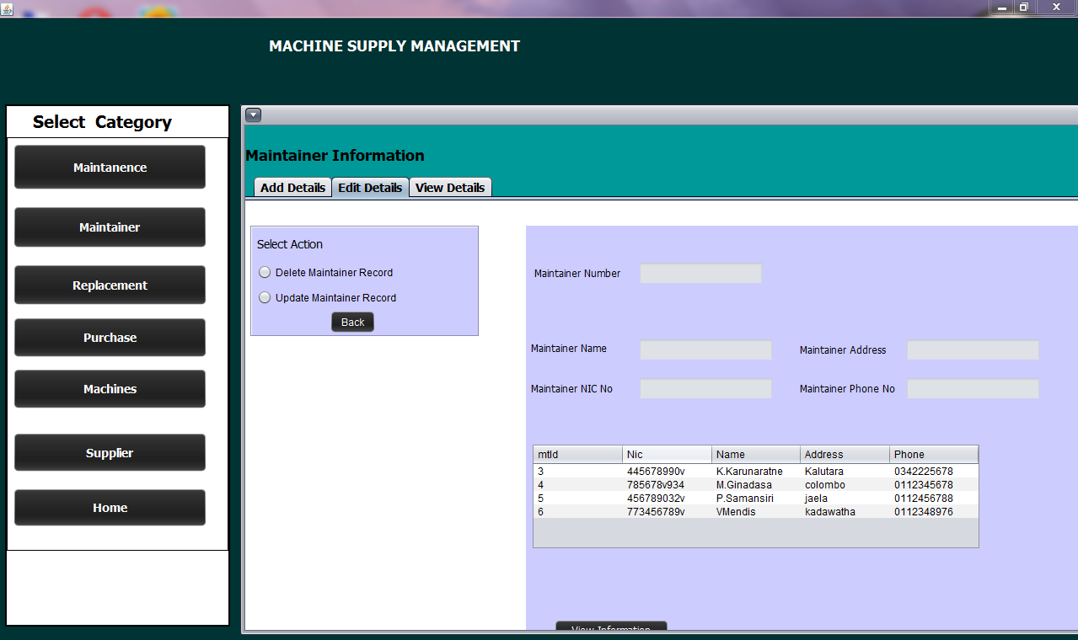

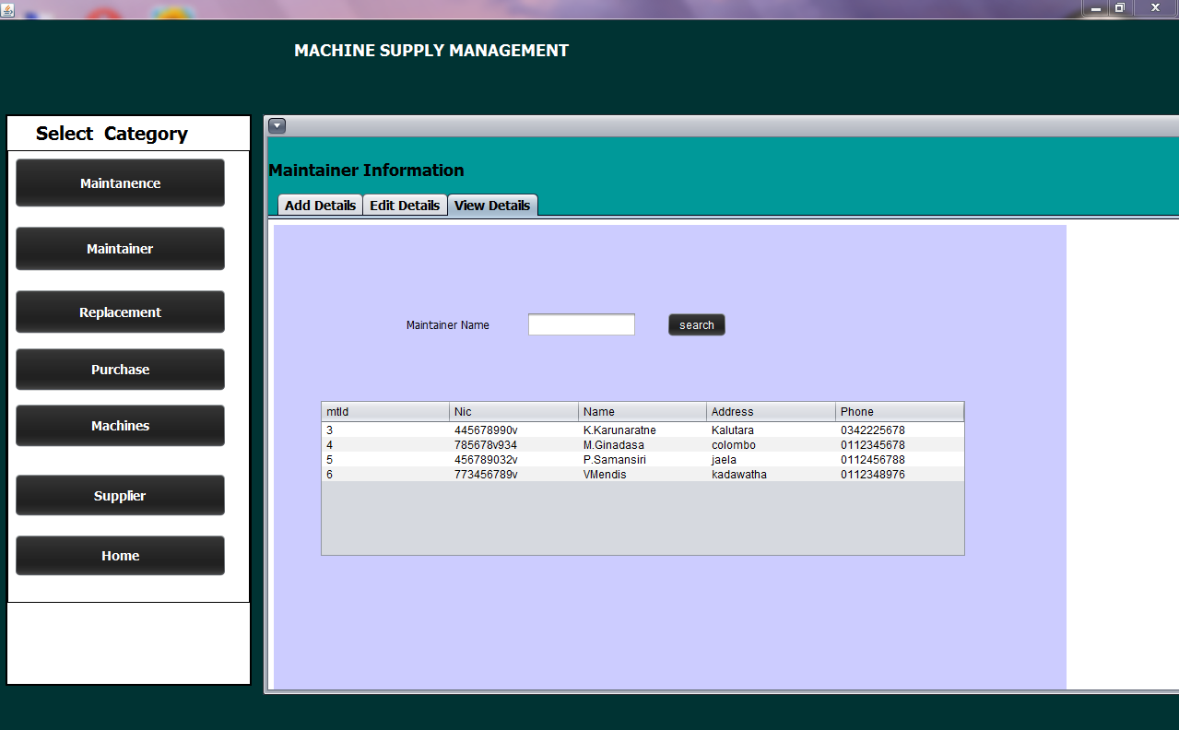

This section consists with 3 sub sections. Add details section provide the facility to add details to the maintainer database. Edit details can be used to update and delete details. Using View Details can view the information.

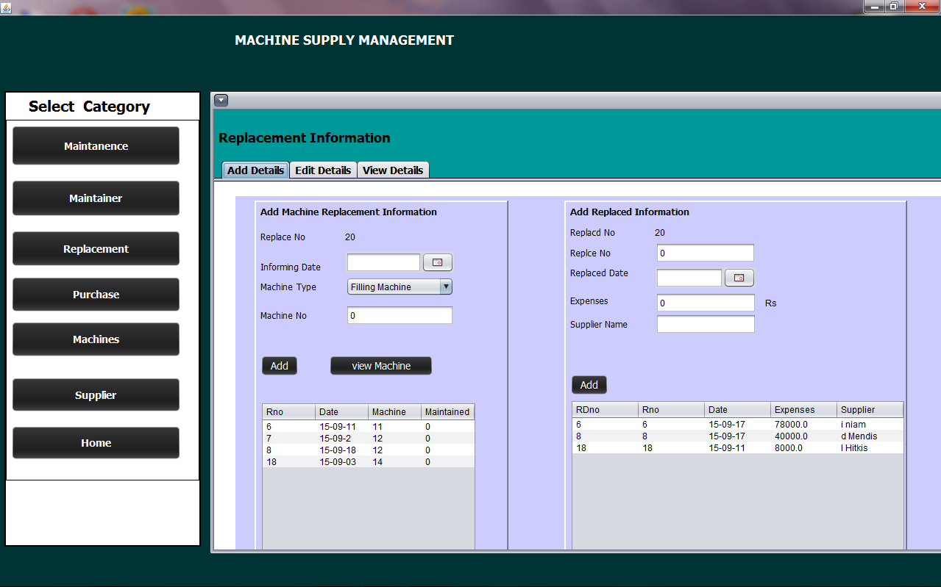Replacement UI

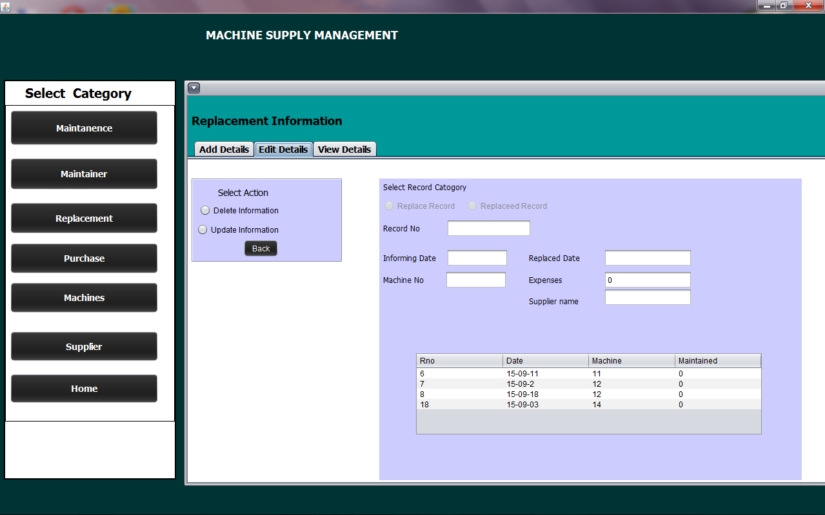

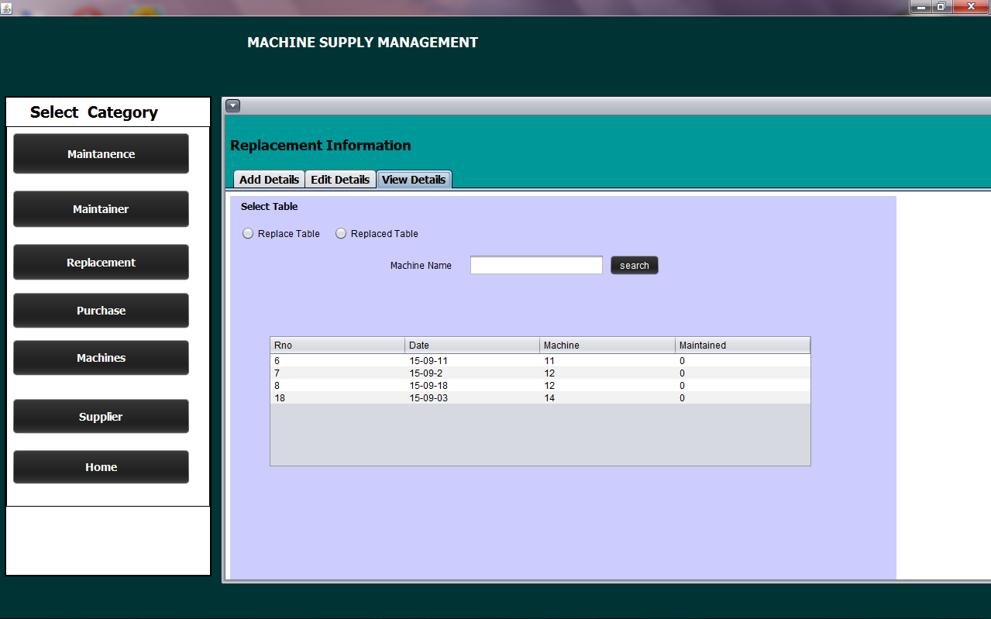

This section consists with 3 sub sections. Add details section provide the facility to add details to the maintenance database. Edit details can be used to update and delete details. Using View Details can view the informations.To add replaced details replacement record of that machine should be in the database.

Purchase UI

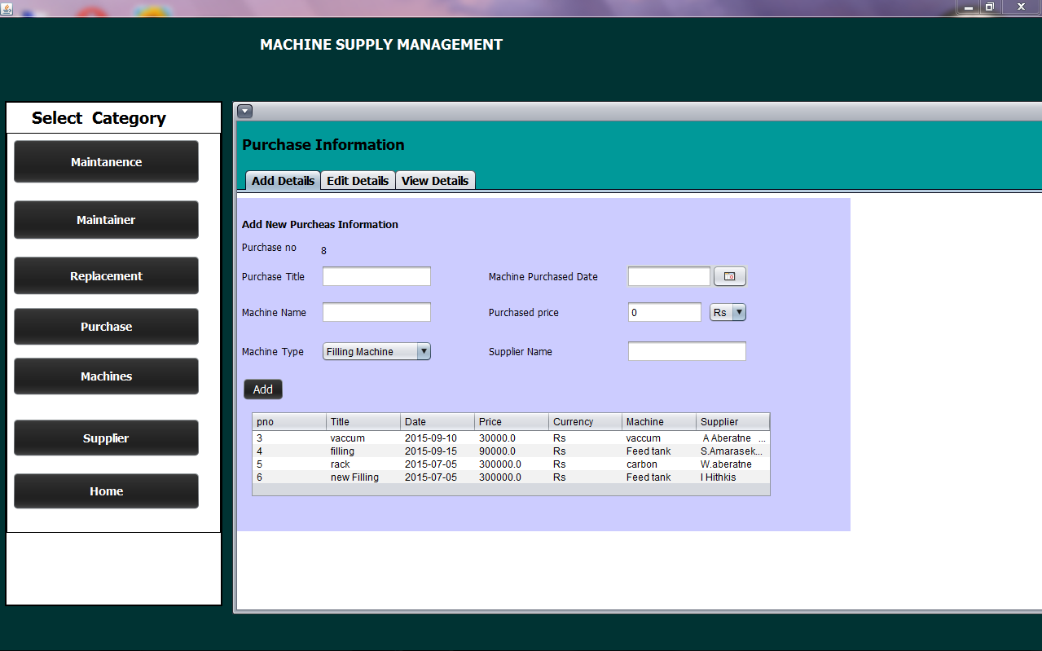

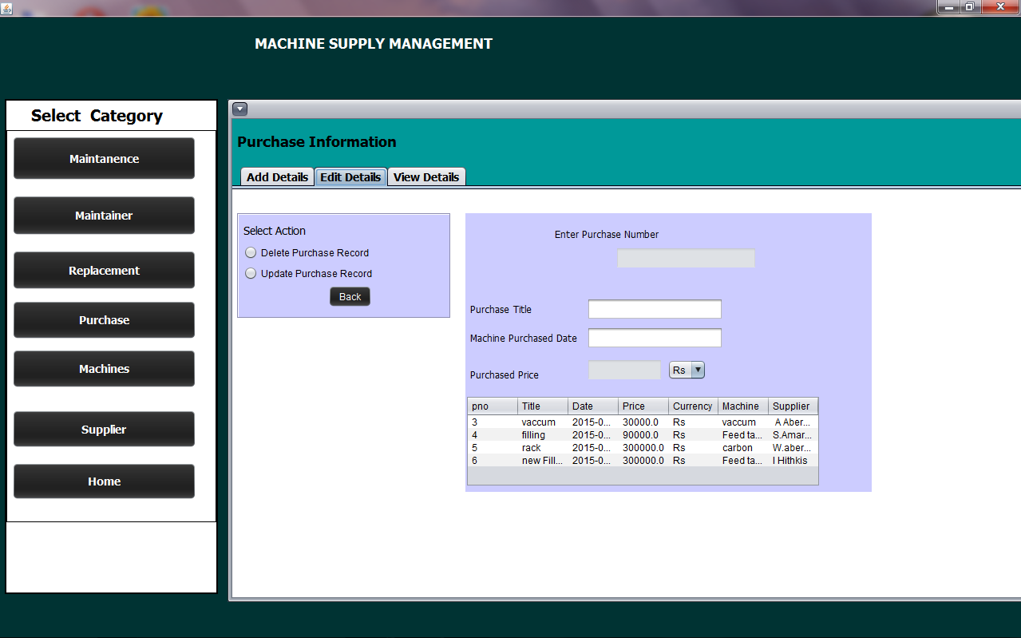

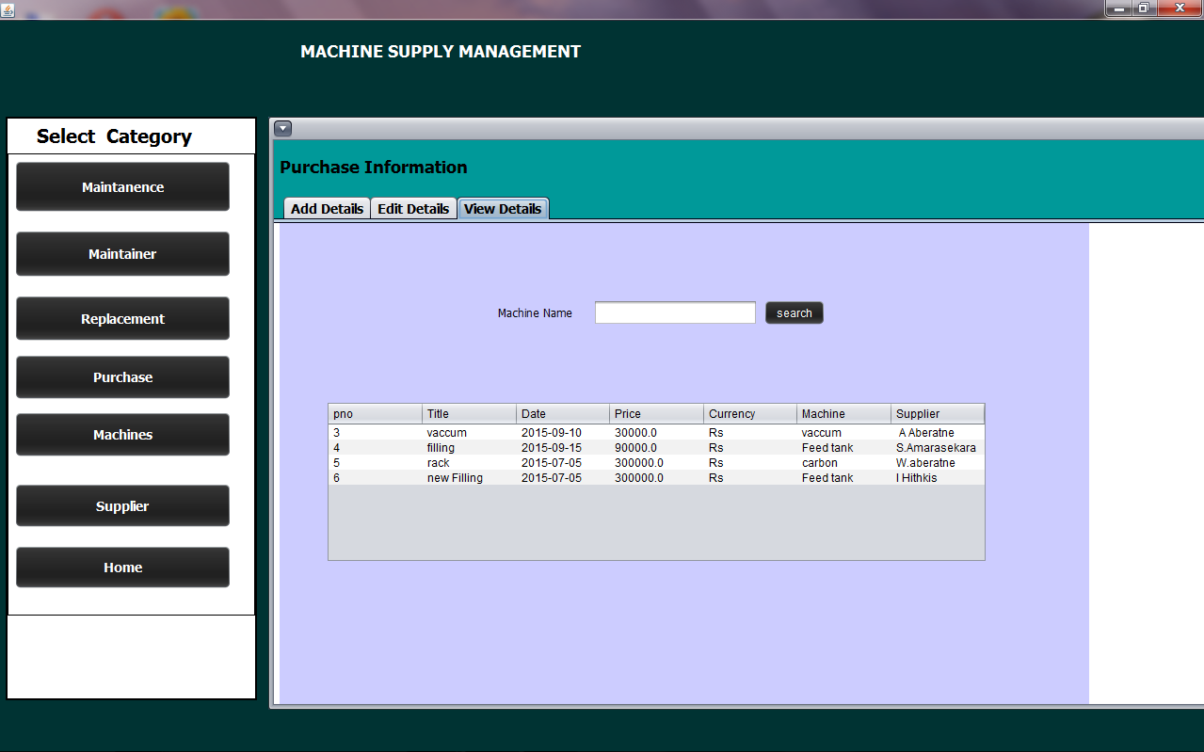

This section consists with 3 sub sections. Add details section provide the facility to add details to the purchase database. Edit details can be used to update and delete details. Using View Details can view the information’s.

Machine UI

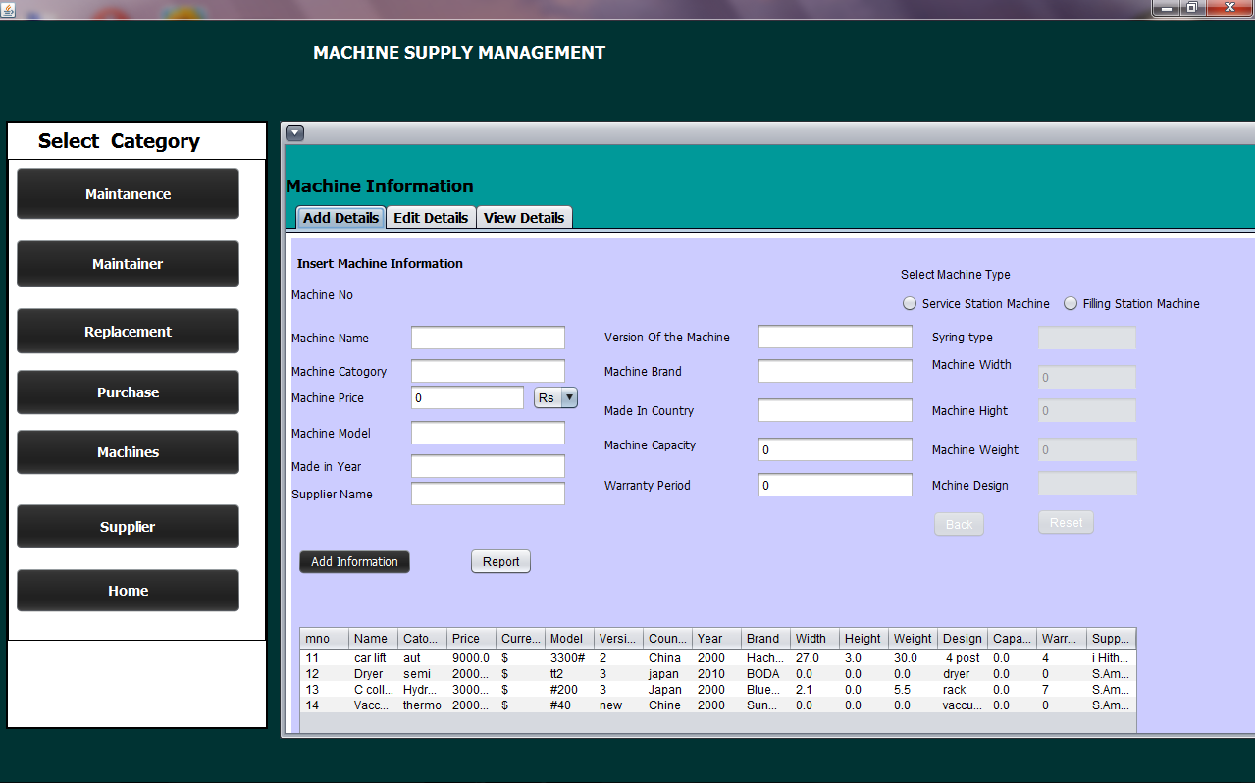





This section consists with 3 sub sections. Add details section provide the facility to add details to the Machines database. Edit details can be used to update and delete details. Using View Details can view the information’s.

Supplier UI

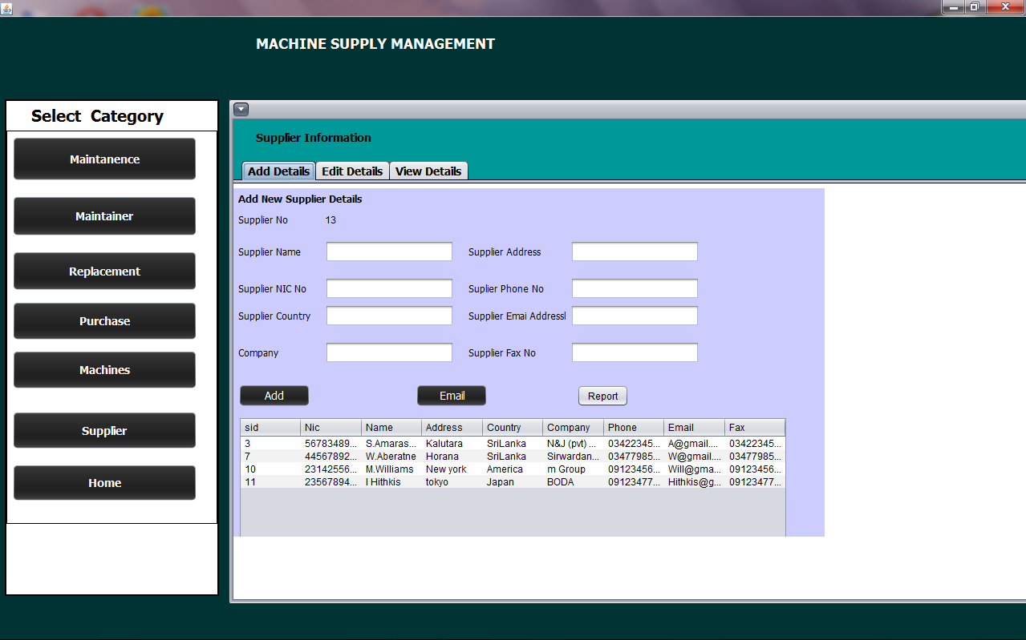

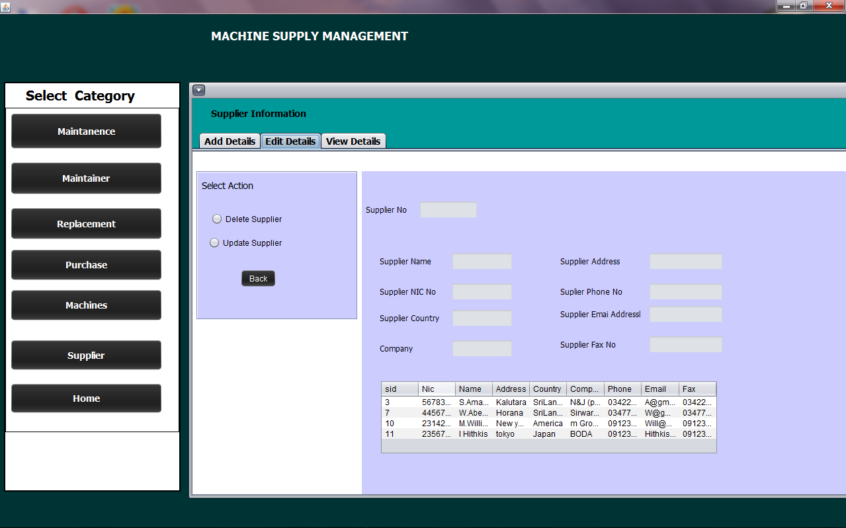

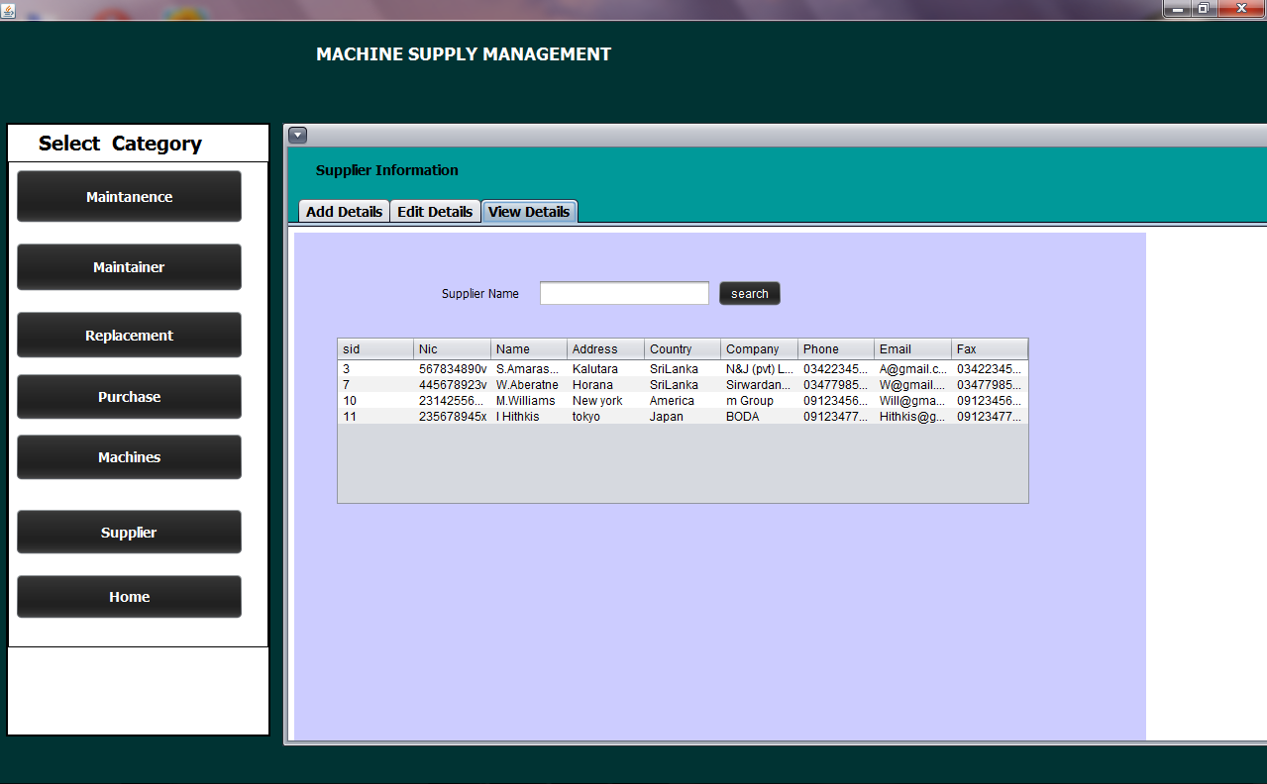

This section consists with 3 sub sections. Add details section provide the facility to add details to the Supplier database. Edit details can be used to update and delete details. Using View Details can view the information’s.

**ATTENDANCE AND PAYROLL MANAGEMENT**

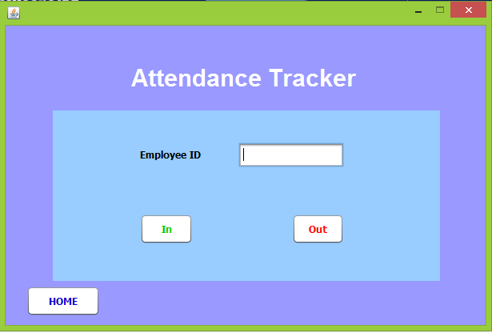

From this interface which is in the employee view, user can mark the attendance.

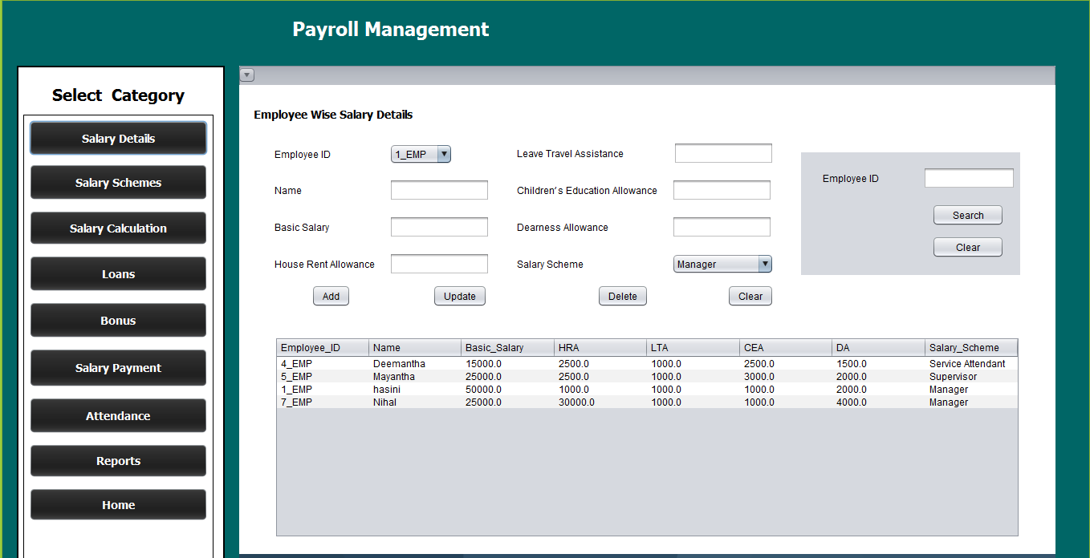

User can add/update/delete/search employee wise salary details from this interface

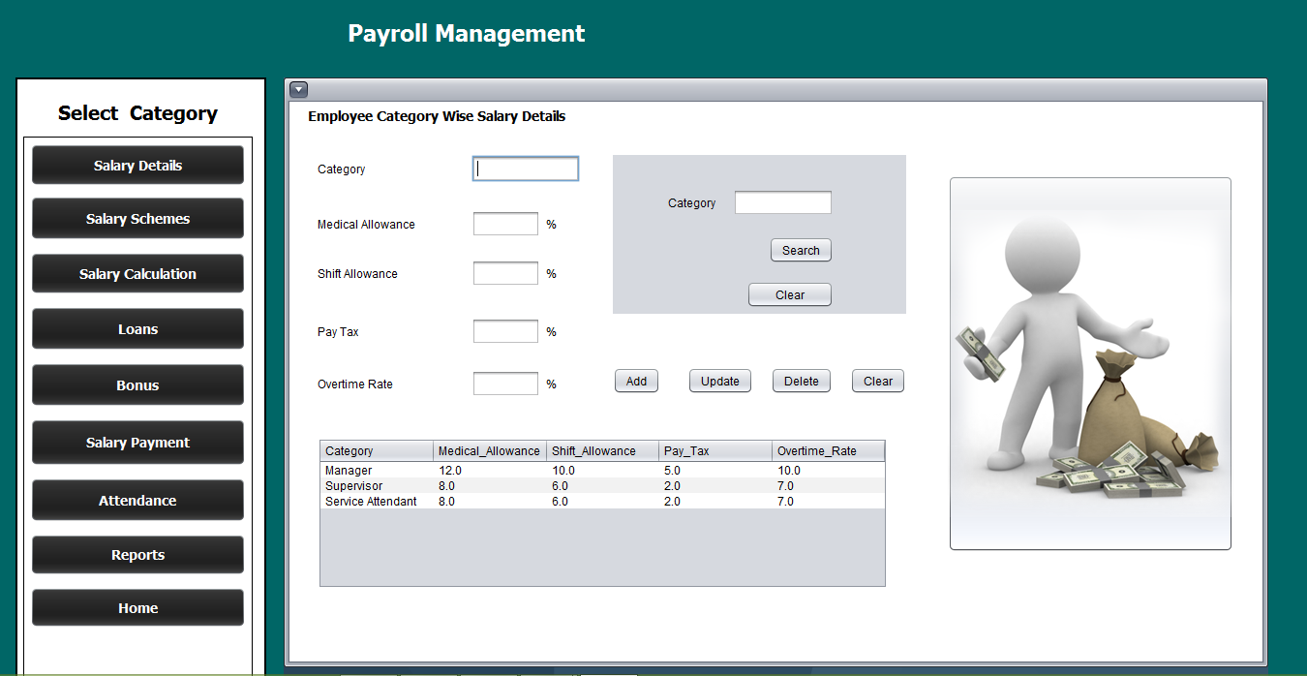

User can add/update/delete/search employee category wise salary details from this interface.

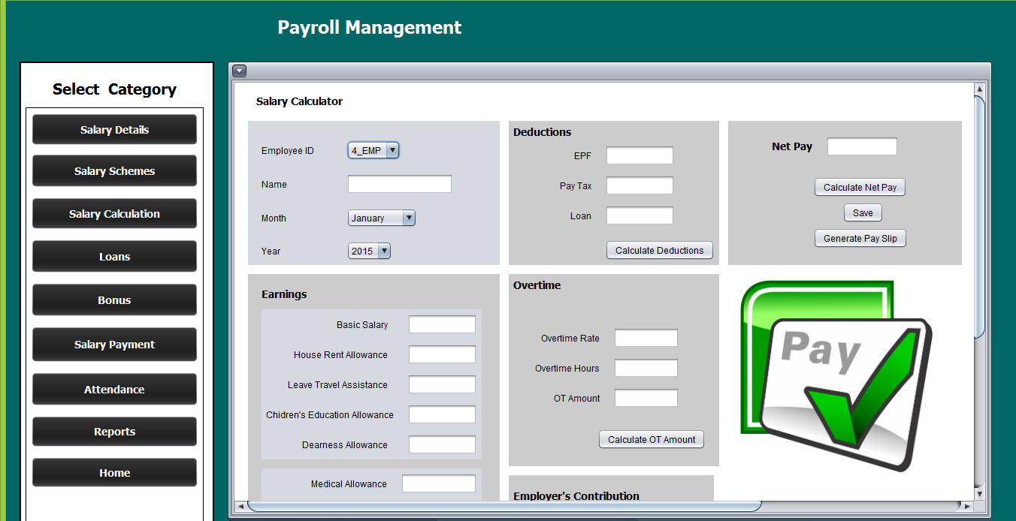

From this interface user can calculate salary for a specific employee in a specific month.

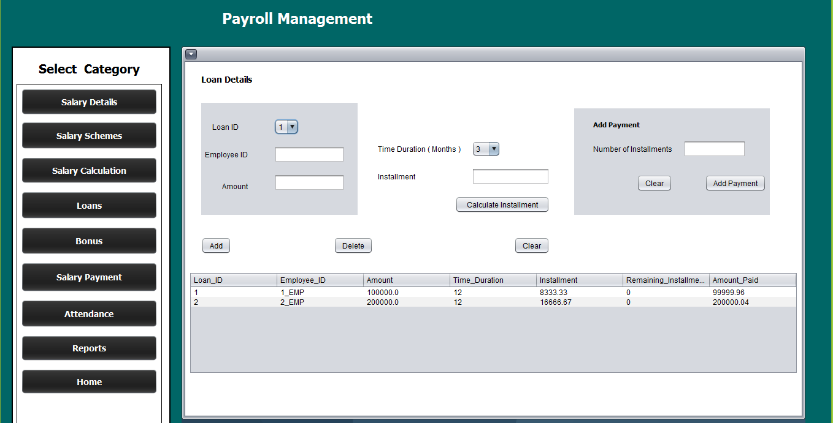

User can calculate loan installments, add payments, and update loan installment details from this window.

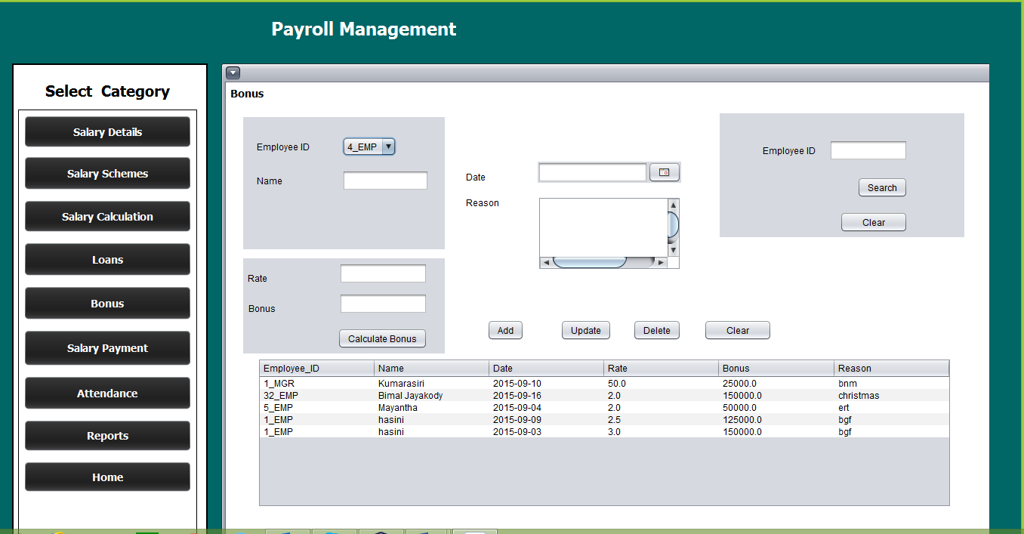

From this window user can calculate bonus by simply entering the bonus rate. And add/update/delete/search bonus details.

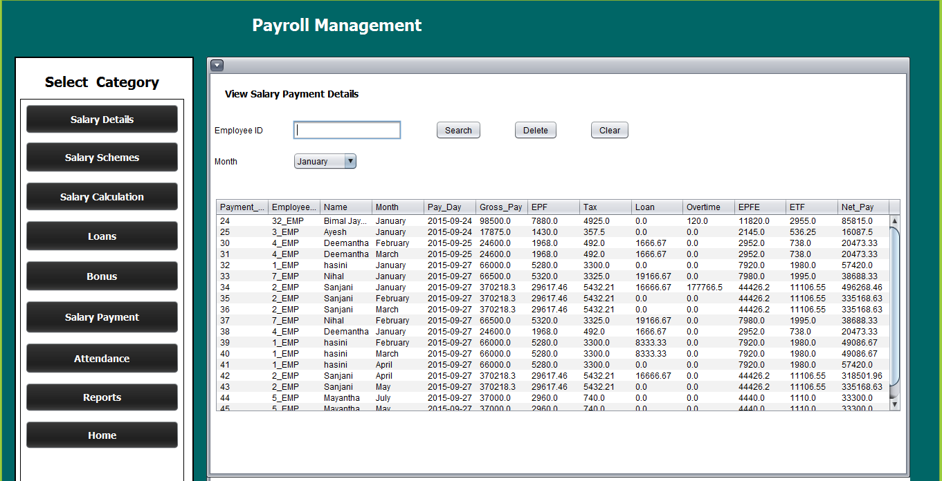

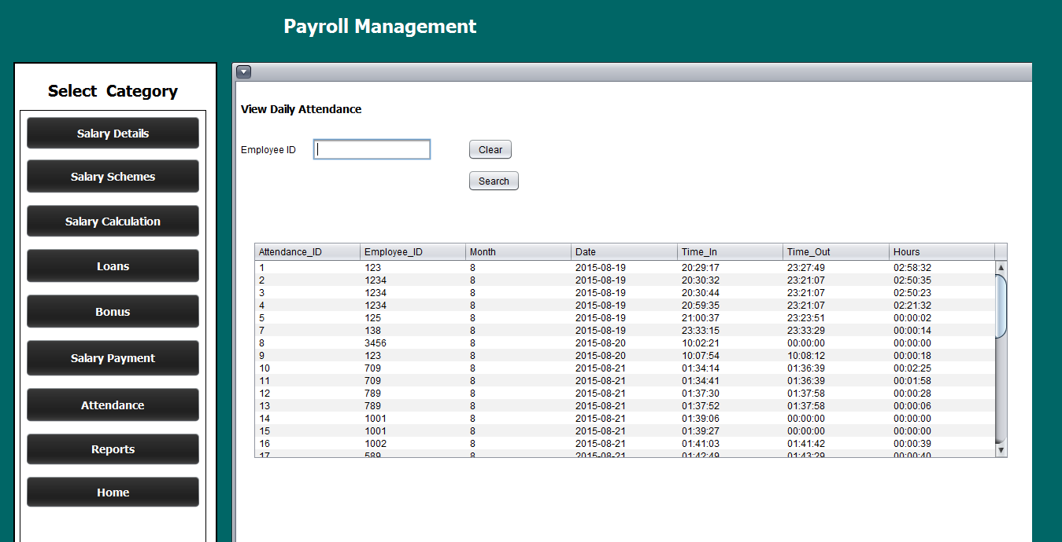

From these two windows user can view/ search employee attendance and salary payment details.

**GENERAL ACCOUNT MANAGEMENT**

Cash Book User Interface

Payment UI

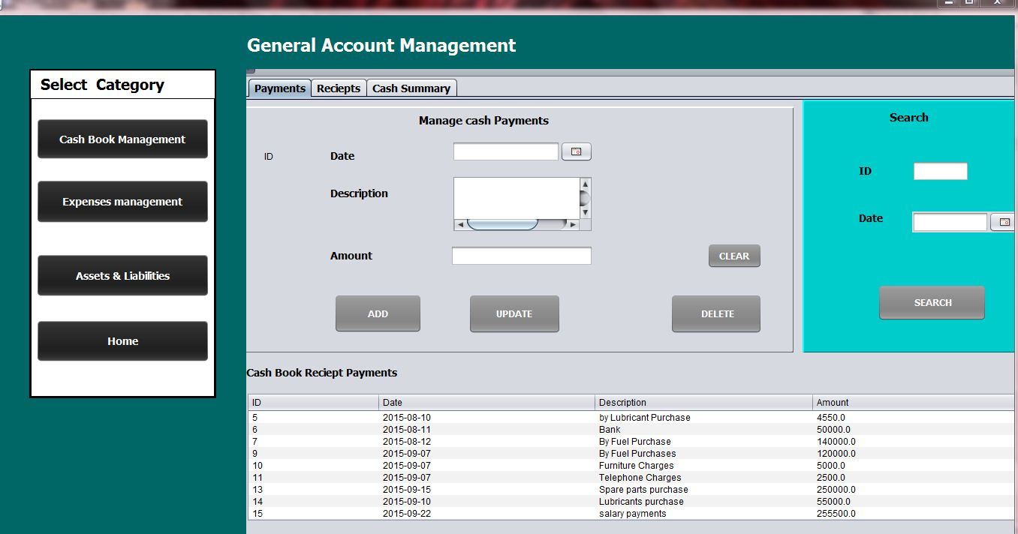

This interface facilitates the user to add/update/delete and search payment (credit) details of the system.

Receipts UI

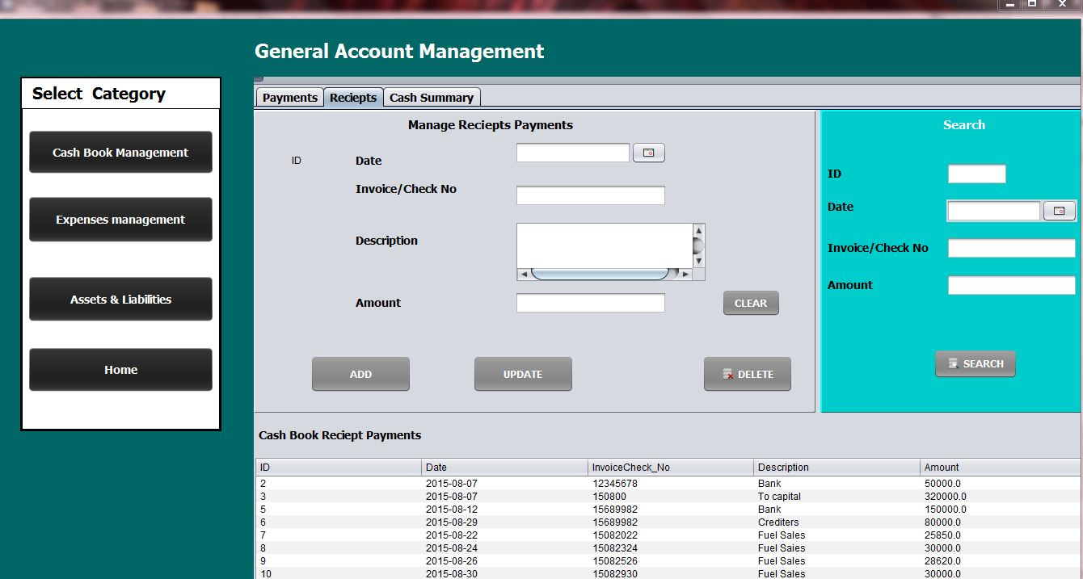

This interface facilitates the user to add/update/delete and search receipts (debit) details of the system.

Cash Summary UI

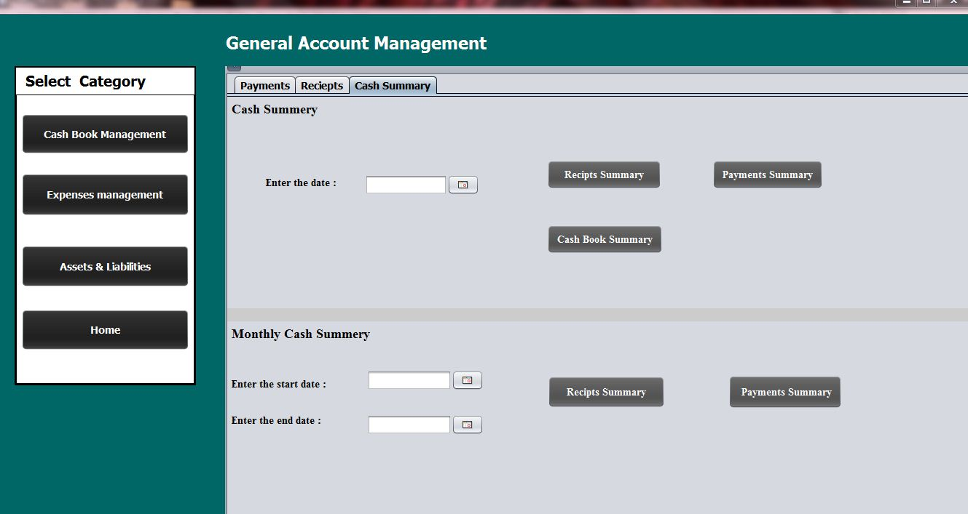

This interface facilitates the user to Generate cash book summery reports.

Cash Book Reports

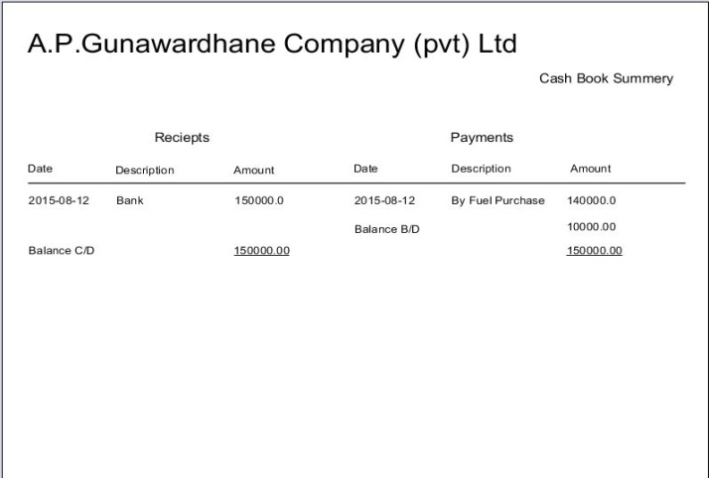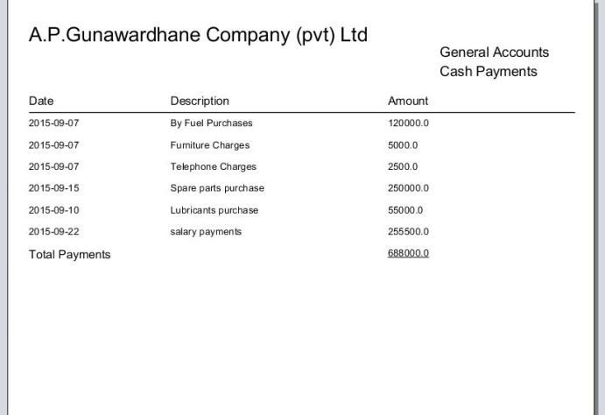

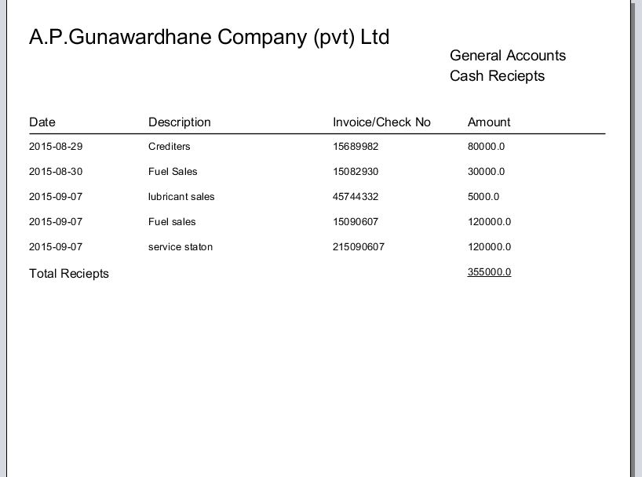

Expenses User Interface

Expenses UI

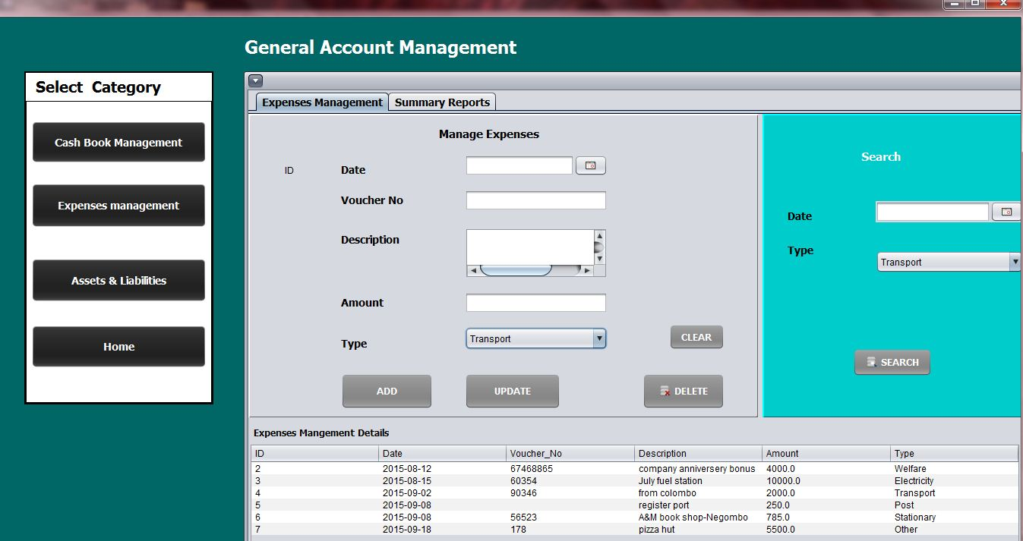

This interface facilitates the user to add/update/delete and search mandatory expenses.

Expenses Summary Reports UI

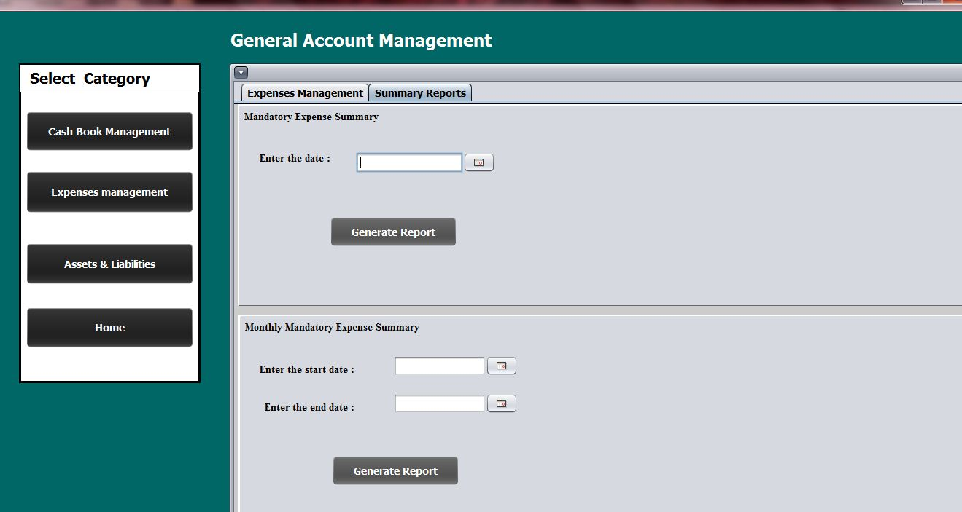

Petty cash Report

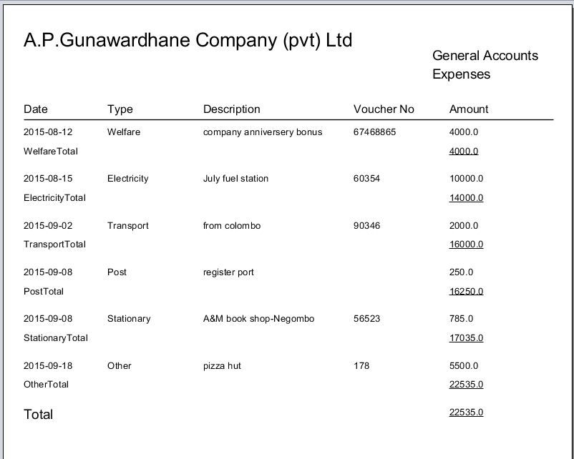

Assets & Liabilities

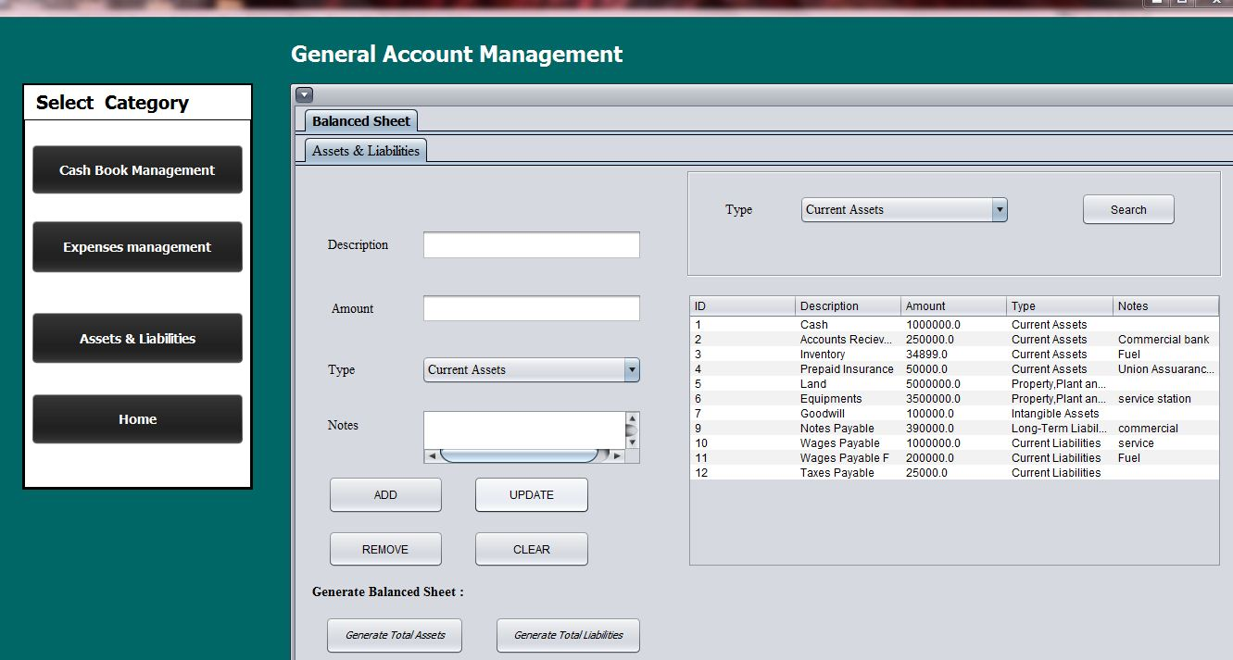

This interface facilitates the user to add/update/delete and search Assets and Liabilities in order to generate balance sheet.

Assets Summary Report

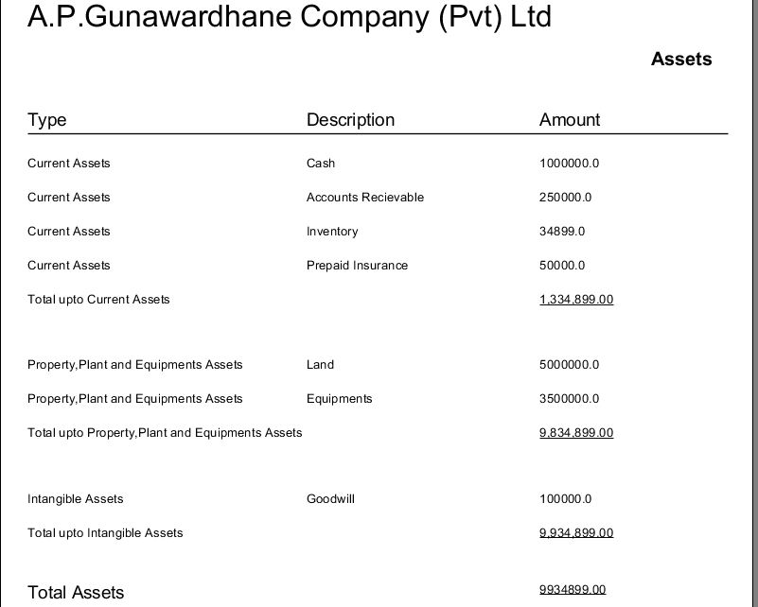

Liabilities Summary Report

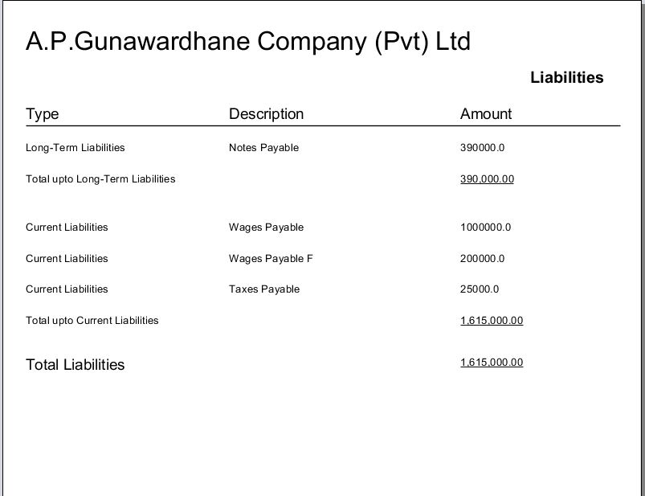

**SERVICE DETAIL MANAGEMENT**

In services details management under MANAGE EMPLOYEE JOBS category user can view customer bookings on selected day by selecting a date from date chooser and clicking view customer bookings button.

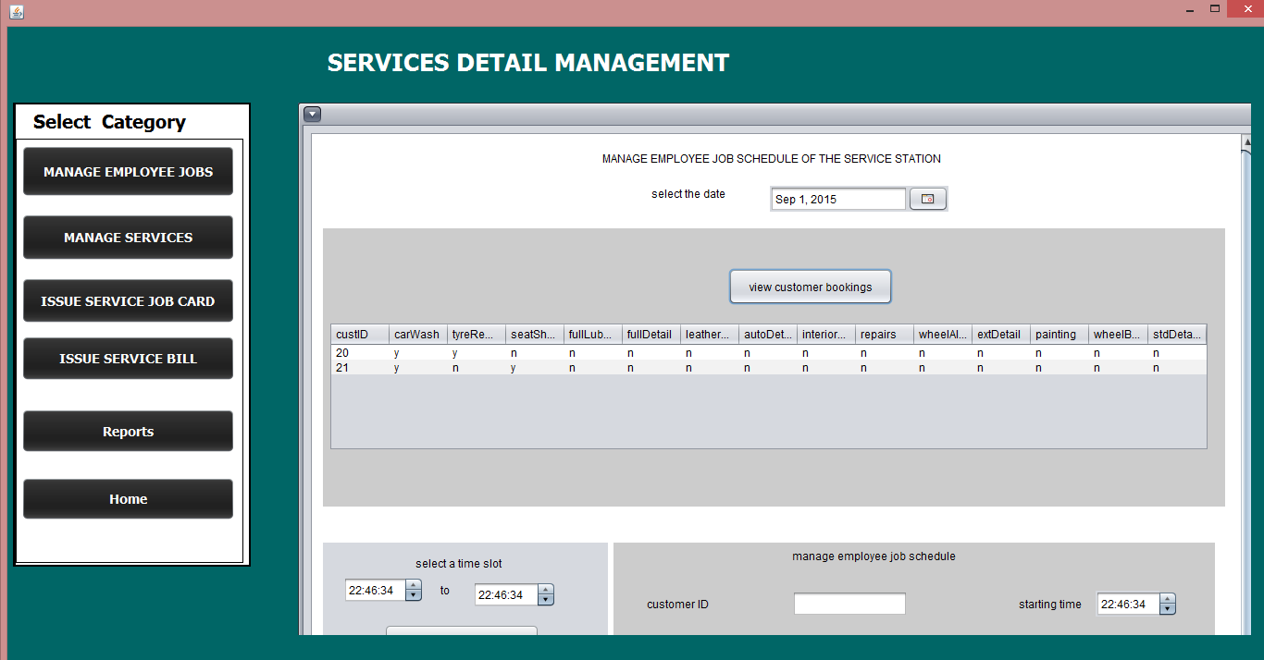

User can view available employees by providing time period and clicking on view available employees’ button. In here user can view previous schedules as well and can insert, delete, update schedule records.

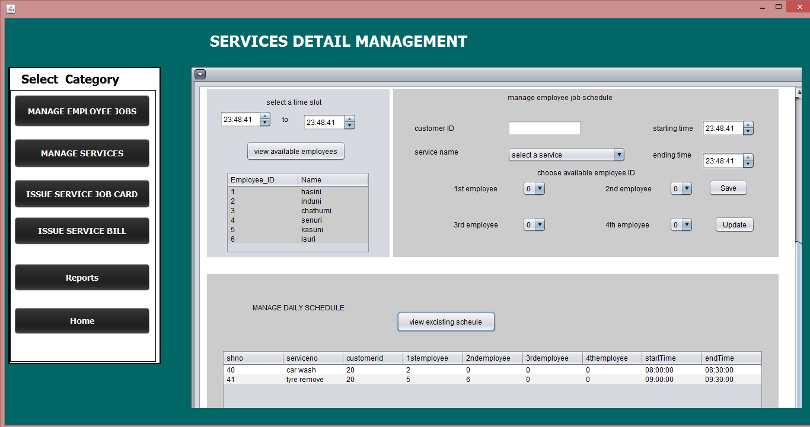

Under MANAGE SERVICES category user can insert, delete, and update service station services.

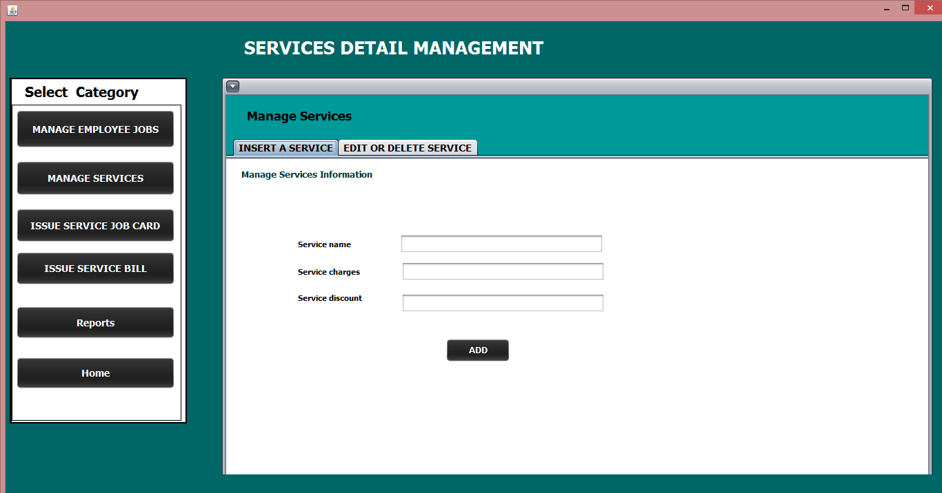

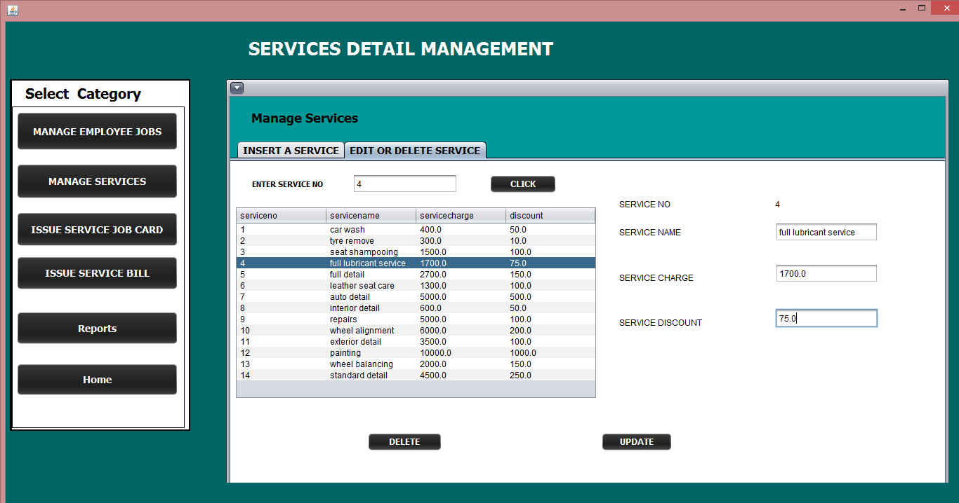

Under ISSUE SERVICE JOB CARD category user has to provide customer code and date and press ENTER button.Then all the fieleds will be filled.and by pressing PRINT JOB CARD button can print the content to a pdf .

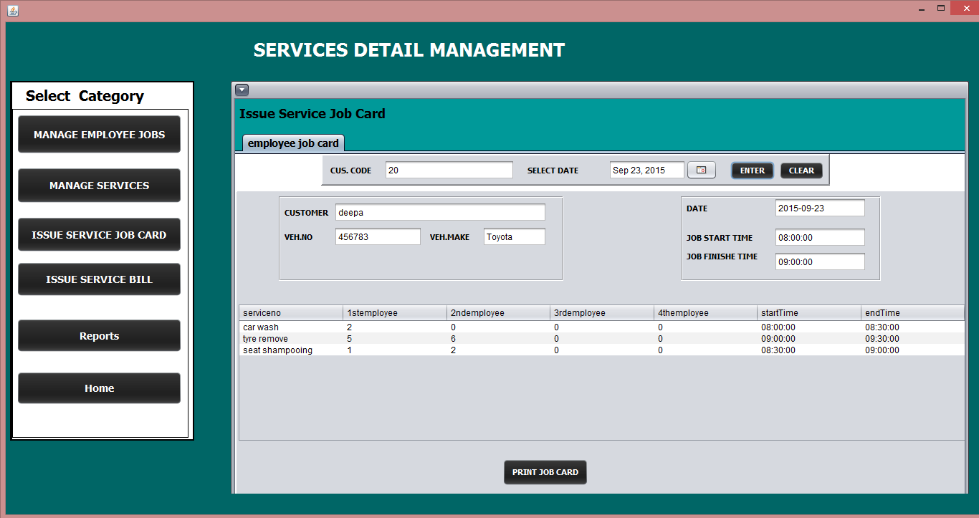

Under ISSUE SERVICE BILL category user should provide customer code ans bill date in ordr to print the bill.User can select services from the combo box and by clicking Add to thebill button service will be added to the table.Total amount will be displayed when clicking on calculate button.

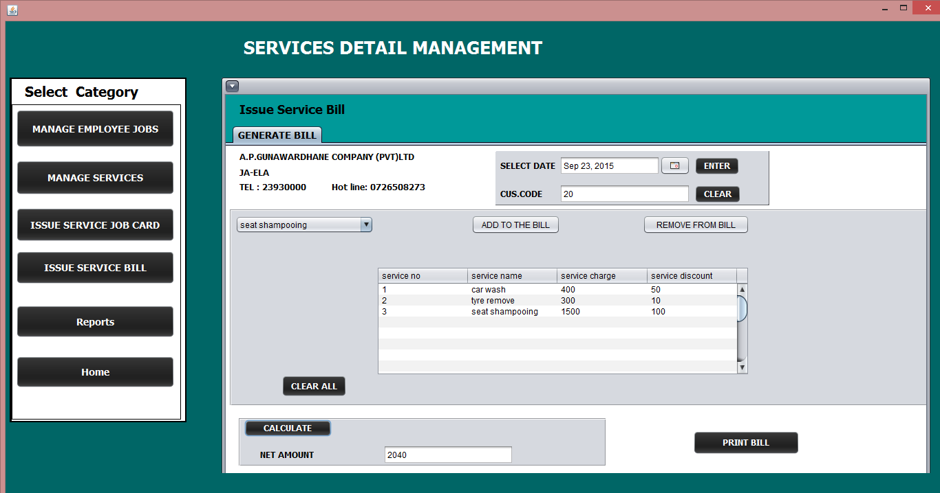

Bill report can generate accorging to given date.

